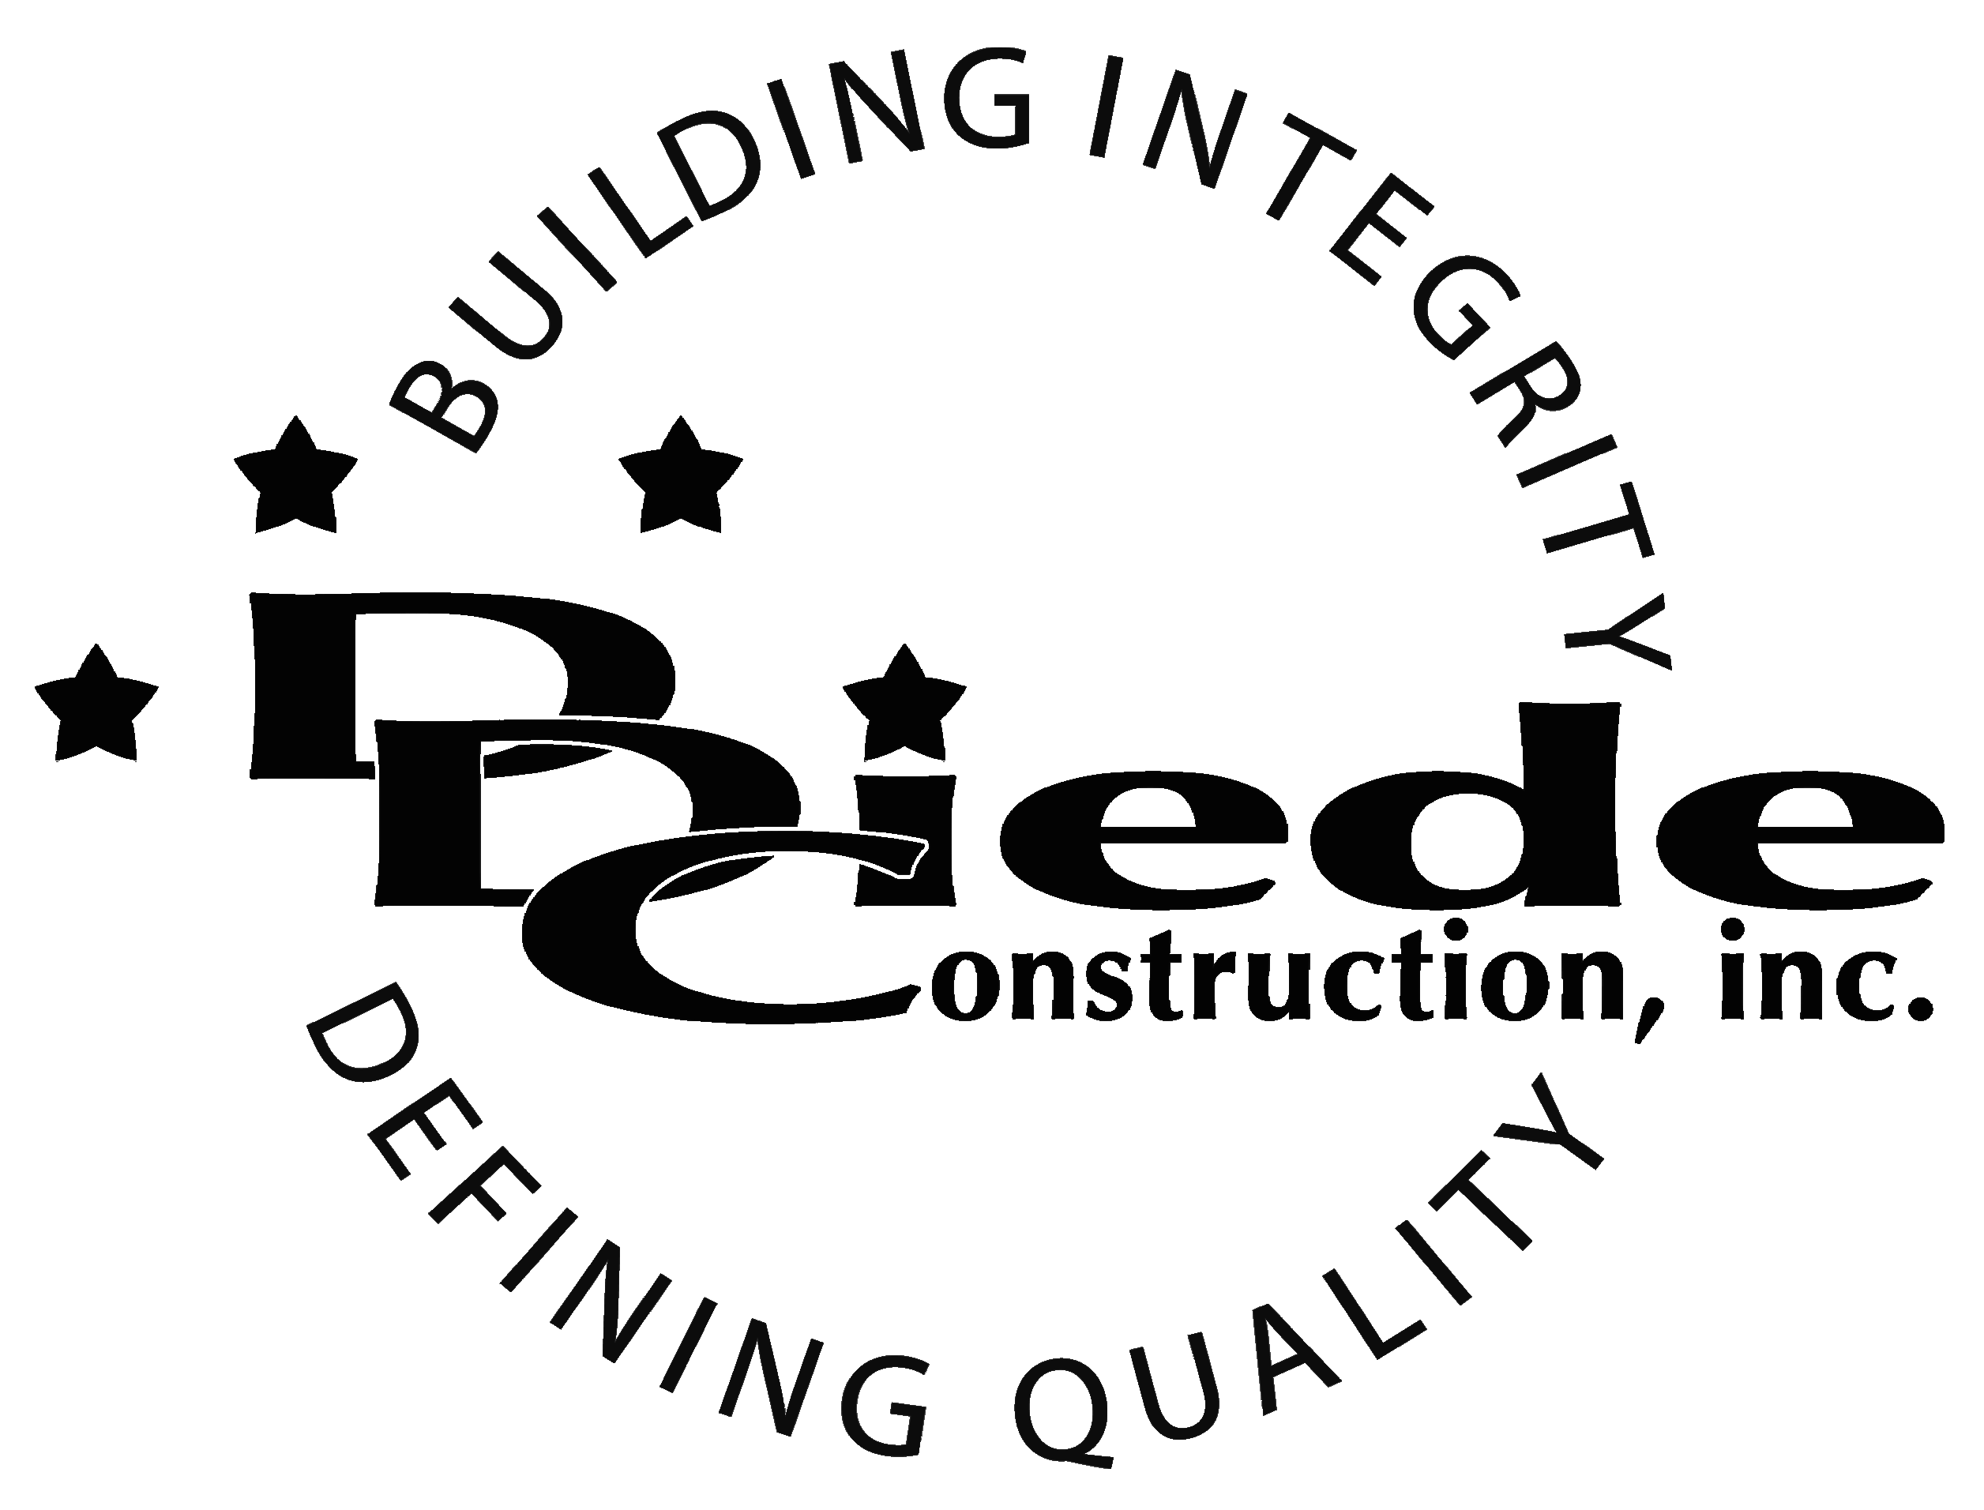
Diede Construction, Inc. Written 04/01/2015
Page 1 of 2

Title: Construction Accountant / Bookkeeper
Company: Diede Construction, Inc.
Locations: Lodi
Description:
Construction Team Accountant / Bookkeeper

Position Summary

The Bookkeeper provides overall bookkeeping support for multiple projects for our Project Management Teams in a high-pressure fast paced environment.

The Bookkeeper of Diede Construction, Inc. has the responsibility for working closely with the Project Teams in providing documentation and administrative support for projects.

Essential Functions
- Responsible for all project administration for their team, including but not limited to:
        - Preparing Budgets
        - Computer Entry of Budgets, Change Orders and Subcontracts
        - Subcontracts Invoice and Pay Outs
        - Creation of Applications for Payment
        - AR Collections and Receipts
        - Generate Job Costs Reports for the PM and Management
        - Analyze and Reconcile all Financial Information on Each Project
- Maintain and prepare all logs and documentation for weekly project meetings
- Cooperate with and assist field personnel (Super’s & Foremen)
- Tactful, Professional Demeanor with the ability to Interact Effectively and Communicate with:
        - Owners
        - Owners Reps
        - Suppliers
        - Subcontractors
        - Managers
- The responsibilities of this position include, but are not limited to those listed above.
Knowledge & Skills
- Proficient in using a computer and the below listed programs:
        - Microsoft Office (Outlook, Word, Excel, etc.)
- Bookkeeping experience a must
- Must be responsible and self-managed
- Must have excellent follow-up and tracking skills
- Must be hands --on, detail oriented and enjoy working in a fast-paced, rapid growth, small company environment.
- Must have a solid understanding of the accounting cycle.
- Minimum 3 years' experience in construction or manufacturing accounting
  - Professional presentation and conduct
  - Ability to multi-task under time constraints and working effectively as a team player in a professional office environment.
  - Demonstrates excellent verbal and written communication skills.
Company Overview
Family-owned Diede Construction, Inc. (DDC) has grown its reputation by building with integrity since 1978. Today we design, build and manage properties throughout multiple states. The company continues to grow based on our ability to handle larger, more complex projects – projects requiring our signature creativity and our comprehensive services.
We build great buildings not by being big, but by thinking big. We build trust by treating our clients, employees and subcontractors like members of the Diede Family. We expedite projects by having a positive, focused attitude.

