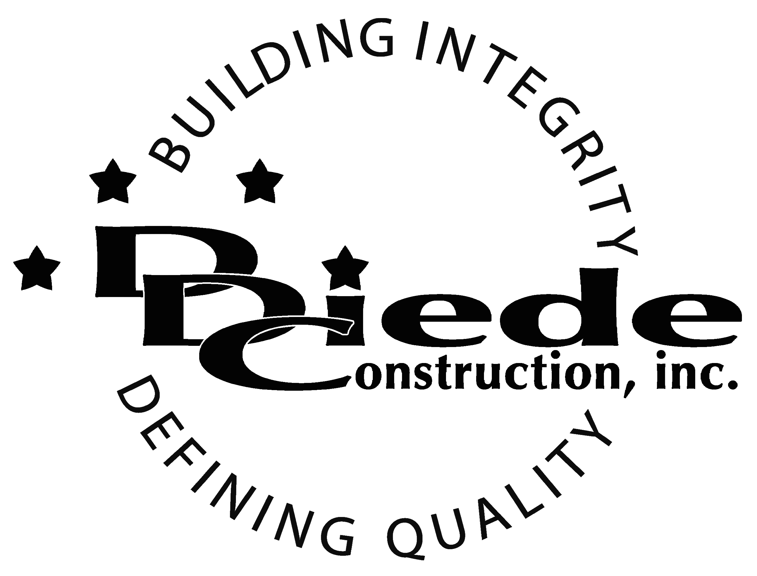
Diede Construction, Inc. Written 07/27/2016
Page 1 of 2

Title: Charge Bookkeeper
Company: Diede Construction, Inc.
Locations: Lodi
Description:
Charge Bookkeeper

Position Summary

The Charge Bookkeeper compiles and accurately maintains bookkeeping records for Diede Construction, Inc. in a high-pressure fast paced environment.

The Charge Bookkeeper of Diede Construction, Inc. has the responsibility for working closely with Management and Accounting providing documentation and administrative support.

Essential Functions
- Responsible for managing and maintaining Diede Construction books, including but not limited to:
        - Balancing, correcting, adjusting and closing general ledger
        - Presenting information to Management and Accounting
        - Reviewing and correcting team information on job profitability and preparing for presentation
        - Creating and submitting ad hoc reports
        - Special projects as requested by management
- Cooperate with and assist management and project teams
- Tactful, Professional Demeanor with the ability to Interact Effectively and Communicate with:
        - Owners
        - Owners Reps
        - Suppliers
        - Subcontractors
        - Managers
- Troubleshoot Viewpoint and continue to help implement additional features
- Provide training for other bookkeepers and financial team
- Collaborate with others on financial team and fill in or help as needed
- The responsibilities of this position include, but are not limited to those listed above.

Knowledge & Skills
- Proficient in using a computer and the below listed programs:
        - Microsoft Office (Outlook, Word, Excel, etc.)
        - Viewpoint or similar Construction Accounting software
- Bookkeeping experience a must
- Must be responsible and self-managed
- Must have excellent follow-up and tracking skills
- Must be hands --on, detail oriented and enjoy working in a fast-paced, rapid growth, small company environment.
- Must have a solid understanding of the accounting cycle.
- Minimum 3 years' experience in construction or manufacturing accounting
  - Professional presentation and conduct
  - Ability to multi-task under time constraints and working effectively as a team player in a professional office environment.
  - Demonstrates excellent verbal and written communication skills.
Company Overview
Family-owned Diede Construction, Inc. (DDC) has grown its reputation by building with integrity since 1978. Today we design, build and manage properties throughout multiple states. The company continues to grow based on our ability to handle larger, more complex projects – projects requiring our signature creativity and our comprehensive services.
We build great buildings not by being big, but by thinking big. We build trust by treating our clients, employees and subcontractors like members of the Diede Family. We expedite projects by having a positive, focused attitude.

