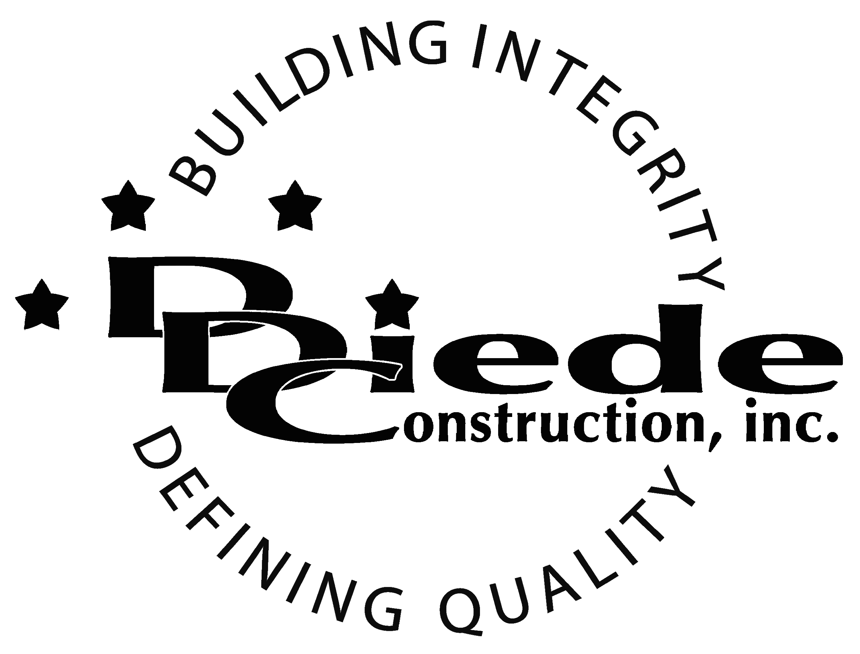
Diede Construction, Inc. Written 09/08/2014
Page 1 of 2

Title: Contract Compliance/Construction Admin.
Company: Diede Construction, Inc.
Locations: Lodi
Description:
Contract Compliance/Construction Admin.

Position Summary

The Contract Compliance Administrator provides overall contract compliance support for multiple projects for our Project Management Teams.

The Contract Compliance Administrator of Diede Construction, Inc. has the responsibility of working closely with the Project Management team to ensure compliance on all projects.

The Contract Compliance Administrator is in contact with subcontractors and insurance companies, which requires tact, sensitivity, and professionalism.

Essential Functions
- Collection of all:
        - Contract Documents
        - Insurance Documents
        - Project Close Out Documents
- Review of said documents for:
        - Accuracy
        - Completeness
- Communicate and correspond with:
        - Subcontractors
        - Lower Tier Subs
        - Insurance Companies
- Responsible to log all in information including:
        - Expiration dates of:
          - Contractor’s License
          - Insurance
        - Documents received
- Handle all calls coming in for warranty. Schedule necessary subcontractors.
- Utilization of the State Contractors board website for verification of licenses.
- The responsibilities of this position include but are not limited to those listed above.
- Implementation of all warranty calls.

Knowledge & Skills
- Proficient in using a computer and the below listed programs:
        - Microsoft Office (Outlook, Word, Excel, etc.)
  - Must have strong organization and time management skills, and the ability to self-motivate.
  - Ability to multi-task under time constraints and working effectively as a team player in a professional office environment.

  - Demonstrates excellent verbal and written communication skills.
  - Ability to perform duties in a professional manner and appearance.
  - Tactful, professional demeanor with the ability to interact effectively with managers, employees, vendors and others.
  - Must have excellent follow through abilities.
  - Construction and/or Insurance background preferred
Company Overview
Family-owned Diede Construction, Inc. (DDC) has grown its reputation by building with integrity since 1978. Today we design, build and manage properties throughout Northern California. The company continues to grow based on our ability to handle larger, more complex projects – projects requiring our signature creativity and our comprehensive services.
We build great buildings not by being big, but by thinking big. We build trust by treating our clients, employees and subcontractors like members of the Diede Family. We expedite projects by having a positive, focused attitude.

