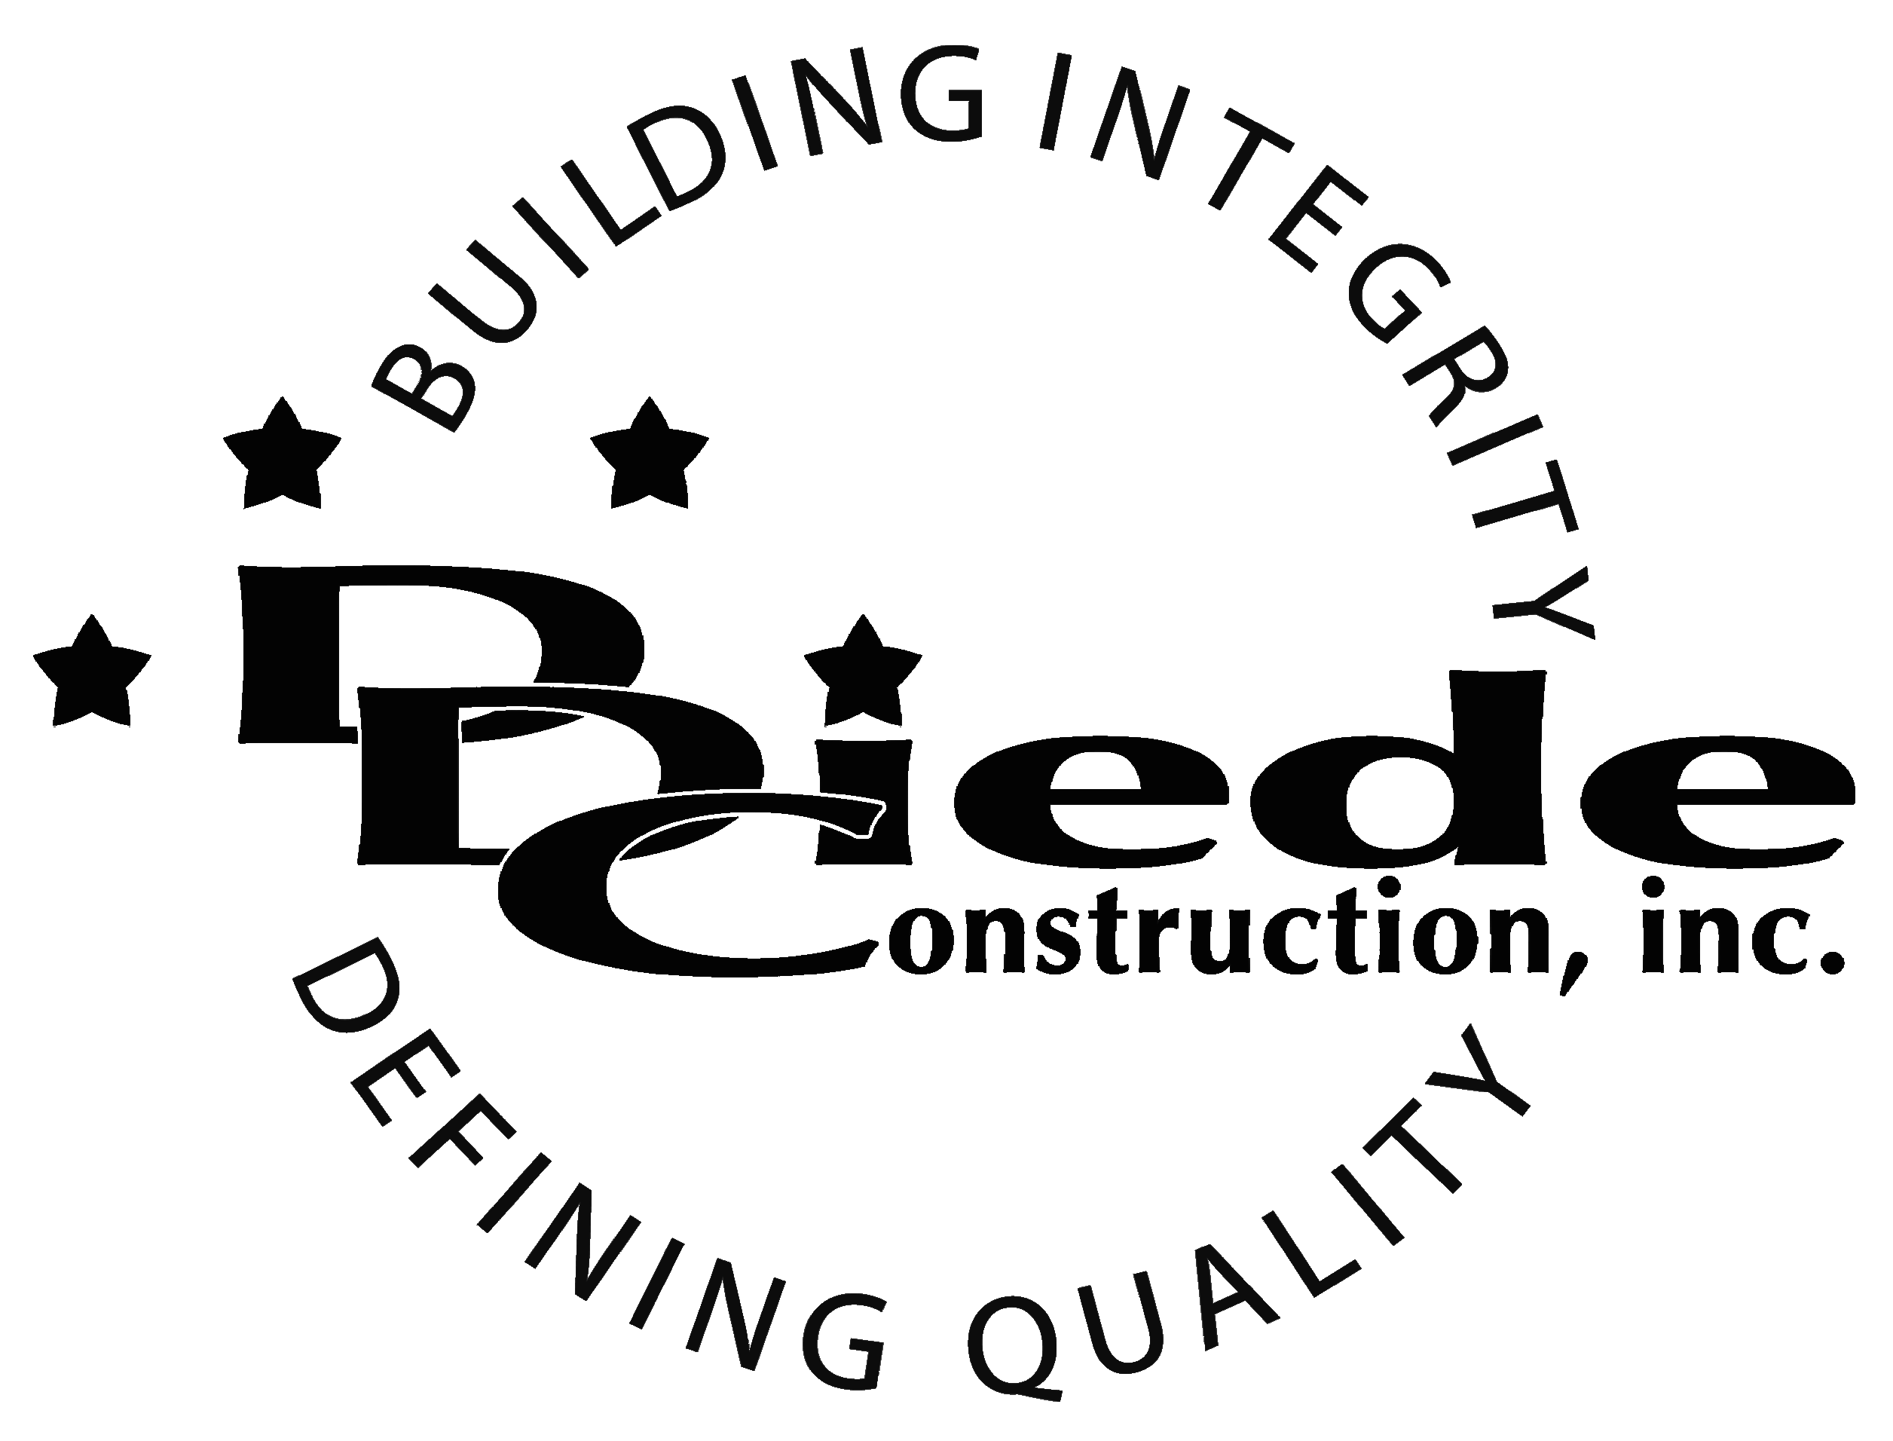
Diede Construction, Inc. Written 09/14/2016
Page 1 of 2

Title: Director of Finance and Accounting
Company: Diede Construction, Inc.
Locations: Lodi
Description:
Director of Finance and Accounting

Position Summary

The Director of Finance and Accounting is responsible for maximizing the return on financial assets by establishing financial policies, procedures, controls and reporting systems.

This position ensures legal and regulatory compliance for all company accounting and financial functions.

The Director of Finance and Accounting is responsible for serving as the leader in the finance and accounting departments and ensuring that financial records for Diede Construction, Inc. are created accurately and in a timely fashion. This position oversees cost and general accounting, accounts receivable and risk management.

Essential Functions
- Works with Senior Management and finance to develop appropriate strategies and procedures for Diede Construction, Inc.
- Establishes monitoring and enforcing policies and procedures in order to guide financial decision and strategies.
- Partners with Senior Management to analyze investments in order to maximize return and limit risk.
- Reports on the financial condition of the company by collecting, interpreting and reporting key financial data.
- Ensures compliance with federal, state, and local requirements by being informed on existing and new legislation and consulting with outside advisors when appropriate.
- Reviews and develops SOPs for the Finance and Accounting team.
- Creates and analyzes budgets
- Oversees year-end closing including:
        - Journal entry adjustments for depreciation expenses & fixed assets
        - Journal entries for any accruals
        - Reconciliation of Federal Income and State Taxes paid
        - Preparation of fiscal year end trial balance
        - Reconciliation of bank accounts, credit cards, and money accounts
        - Preparation of tax forms
- Collaborates in areas such as compensation, benefits, and asset protection
- Provides training and mentoring to other members of the Financial team
- Tactful, Professional Demeanor with the ability to Interact Effectively and Communicate with:
        - Owners
        - Investors
        - Lenders
        - Regulatory Agencies
- Collaborate with others on financial team
- The responsibilities of this position include, but are not limited to those listed above.

Knowledge & Skills
The Director of Finance and Accounting must have passed the Uniform Certified Public Accountant examination and have met or be in the process of meeting additional state education and experience requirements for certification as a CPA.
- Proficient in using a computer and the below listed programs:
        - Microsoft Office (Outlook, Word, Excel, etc.)
        - Viewpoint or similar Construction Accounting software
        - Quickbooks
- This position is directly responsible for leading managers in the finance and accounting division
- Must have excellent follow-up and tracking skills
- Must be detail oriented and enjoy working in a fast-paced, rapid growth, family owned company environment.
- Must have a solid understanding of the accounting cycle.
- Experience in construction or manufacturing
  - Professional presentation and conduct
  - Ability to multi-task under time constraints and working effectively as a team player in a professional office environment.
  - Bachelor’s degree in a business, financial or related field (Master’s degree preferred) or equivalent work experience.
  - 5+ years managing an accounting function in a medium-large size company.
  - Demonstrates excellent verbal and written communication skills.
Company Overview
Family-owned Diede Construction, Inc. (DDC) has grown its reputation by building with integrity since 1978. Today we design, build and manage properties throughout multiple states. The company continues to grow based on our ability to handle larger, more complex projects – projects requiring our signature creativity and our comprehensive services.
We build great buildings not by being big, but by thinking big. We build trust by treating our clients, employees and subcontractors like members of the Diede Family. We expedite projects by having a positive, focused attitude.

