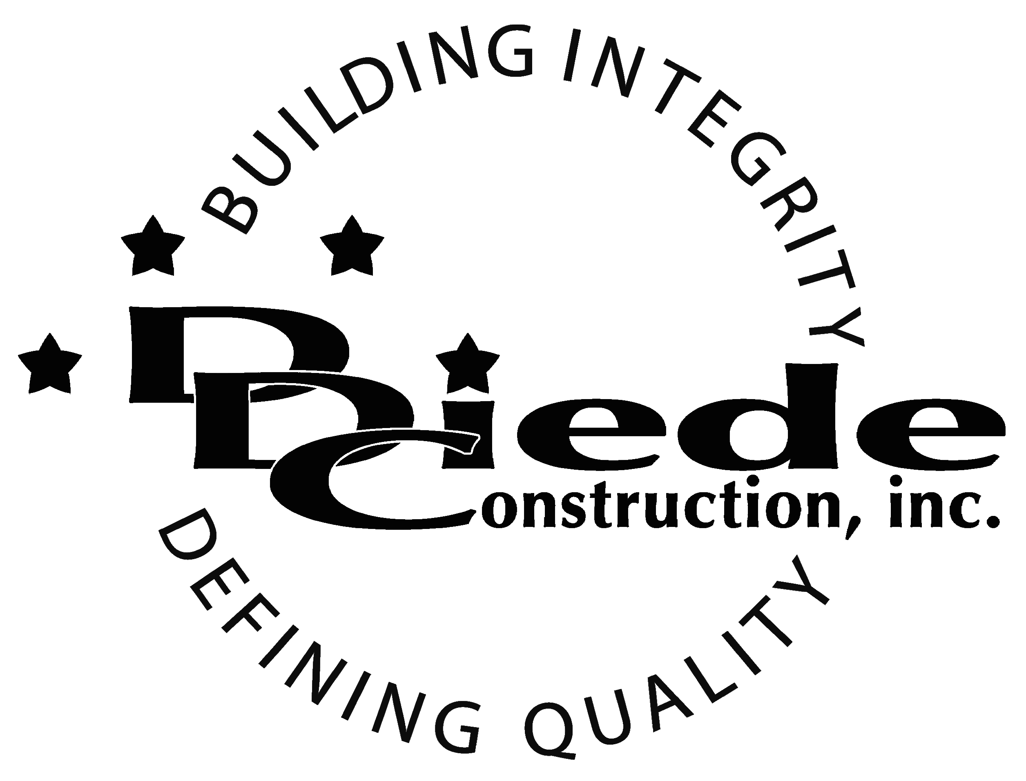
Diede Construction, Inc. Written 11/28/2017
Page 1 of 2

Title: Director of Strategic Initiatives
Company: Diede Construction, Inc.
Locations: Lodi
Description:
Director of Strategic Initiatives

Position Summary

The Director of Strategic Initiatives is responsible to managing, overseeing, and putting plans and goals in place to advance the company’s short term and long-term goals.

The Director works with the executive team to develop programs, ideas and strategies and, in some cases may oversee budgeting and manage funds to help move the business forward. The director also prepares documents and presentations for internal and external stakeholders.

The Director of Strategic Initiatives must be articulate, decisive, able to multitask, manage time and work under pressure to meet various deadlines. Networking and building beneficial relationships with other companies, potential clients and partners, and various other entities are a crucial part of this position.

Essential Functions
- Works with the executive team to identify viable opportunities in each of the organizations respective markets that align with the company’s objectives and vision.
- Perform due diligence and entitlement on land development
- Lead development, implementation and operations per the guidelines set forth by the company
- Collaborates with management to develop Key Performance Indicators and Standard Operating Procedures for all pilot programs
- Partners with various departments to develop and implement operational reports
- Contributes to the development, creation and implementation of all training programs related to all pilot programs
- Partners with the preconstruction development team to create and implement any program related upgrades, additions or supplements
- Performs market analysis to identify areas that are appropriate for business development opportunities.
- Partners with Human Resources to staff pilot programs’ workforce.
- Updates the Executive team on performance of pilot programs and develops reports for ongoing management
- Manage the daily operations and development of specific corporate programs
- Demonstrates knowledge of and supports mission, vision and value statements. Maintains extensive knowledge of the company’s current operations practices and protocols, management practices, business processes and procedures.
- Identify opportunities for process improvements and the creation of best practices
- Conducts and participates in a variety of meetings including management meetings, cross functional meetings, and various committees
- Assists in planning of any event that highlights corporate services. Performs public speaking and presentations to organizations and committees regarding public relations and development.
- Performs other duties and special projects as assigned

Knowledge & Skills
- Proficient in using a computer and the below listed programs:
        - Microsoft Office (Outlook, Word, Excel, etc.)
        - PowerPoint and/or other presentation software
- The ability and skills to build effective working relationships with staff, customers, community groups and others.
- Must have excellent follow-up and tracking skills
- Must be detail oriented and enjoy working in a fast-paced, rapid growth, family owned company environment.
- Experience in construction, real estate development, hospitality or manufacturing
  - Professional presentation and conduct
  - Ability to multi-task under time constraints and working effectively as a team player in a professional office environment.
  - Bachelor’s degree in a business, financial or related field (Master’s degree preferred) or equivalent work experience.
  - 5+ years in a business development or strategic partnership role.
  - Demonstrates excellent verbal and written communication skills.
  - Must have exceptioinal analytical skills and the ability to interpret and provide in depth analysis of multiple sources of data.
Company Overview
Family-owned Diede Construction, Inc. (DDC) has grown its reputation by building with integrity since 1978. Today we design, build and manage properties throughout multiple states. The company continues to grow based on our ability to handle larger, more complex projects – projects requiring our signature creativity and our comprehensive services.
We build great buildings not by being big, but by thinking big. We build trust by treating our clients, employees and subcontractors like members of the Diede Family. We expedite projects by having a positive, focused attitude.

