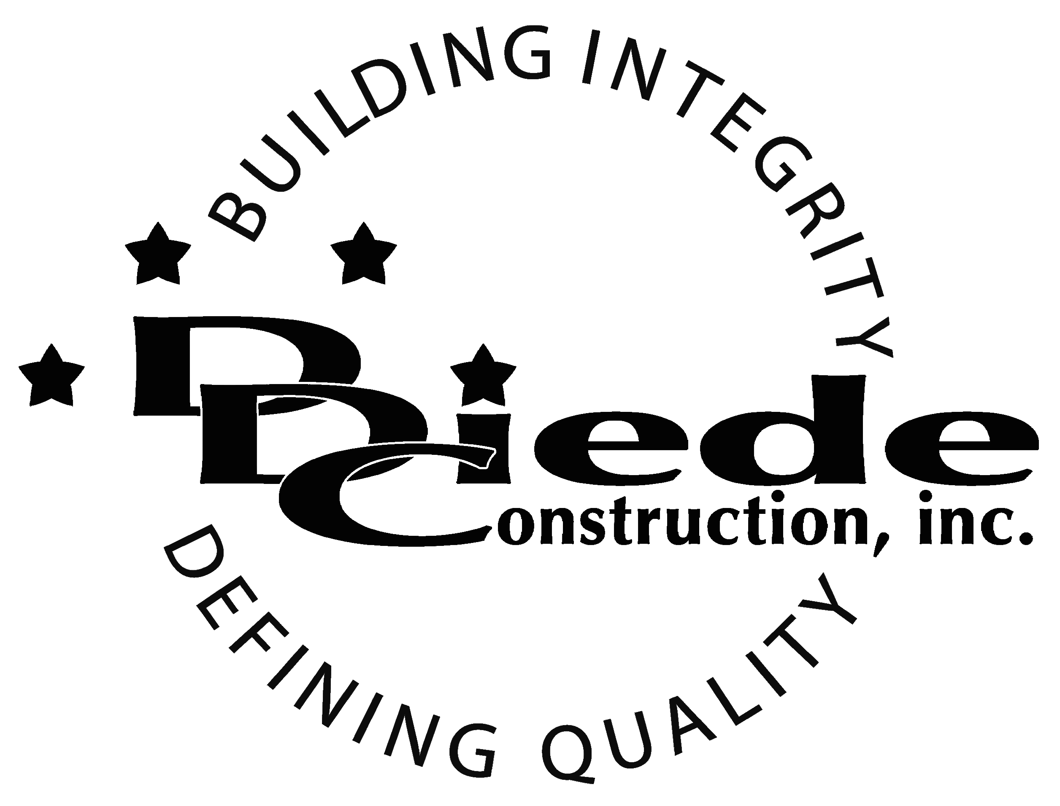
Diede Construction, Inc. Written 11/21/2017
Page 1 of 2

Title: Construction Estimating Assistant
Company: Diede Construction, Inc.
Locations: Lodi
Description:
Construction Estimating Assistant

Position Summary

The Estimating Assistant provides overall support for the Estimating department.

The Estimating Assistant has the responsibility of working closely with the Estimating department to ensure they are familiar with the projects that are bidding and providing subcontractors with information on the project as necessary.

The Estimating Assistant will assist the estimating department in all facets of the bidding process and assist the Project Teams as necessary.

Essential Functions
  - Performs administrative tasks in support of the estimating department.
  - Helps determine scopes of work and provides assistance with all estimates
  - Assists with the development of schedules for projects
- Must be prepared to bid multiple projects per week
- Communicate with:
        - Owners
        - Owners Reps
        - Architects
        - Engineers
        - Subcontractors
- The responsibilities of this position include, but are not limited to those listed above.
Knowledge & Skills
- Proficient in using a computer and the below listed programs:
        - Microsoft Office (Outlook, Word, Excel, etc.)
  - Must have strong organization and time management skills, and the ability to self-motivate.
  - Ability to multi-task under time constraints and working effectively as a team player in a professional office environment.
  - Demonstrates excellent verbal and written communication skills.
  - Ability to perform duties in a professional manner and appearance.
  - Tactful, professional demeanor with the ability to interact effectively with managers, employees, vendors and others.
  - Ability to read, understand and organize plans
  - Ability to read and understand Specification books
  - Experience or hands on knowledge of the Construction industry

Company Overview
Family-owned Diede Construction, Inc. (DDC) has grown its reputation by building with integrity since 1978. Today we design, build and manage properties throughout Northern California. The company continues to grow based on our ability to handle larger, more complex projects – projects requiring our signature creativity and our comprehensive services.
We build great buildings not by being big, but by thinking big. We build trust by treating our clients, employees and subcontractors like members of the Diede Family. We expedite projects by having a positive, focused attitude.

