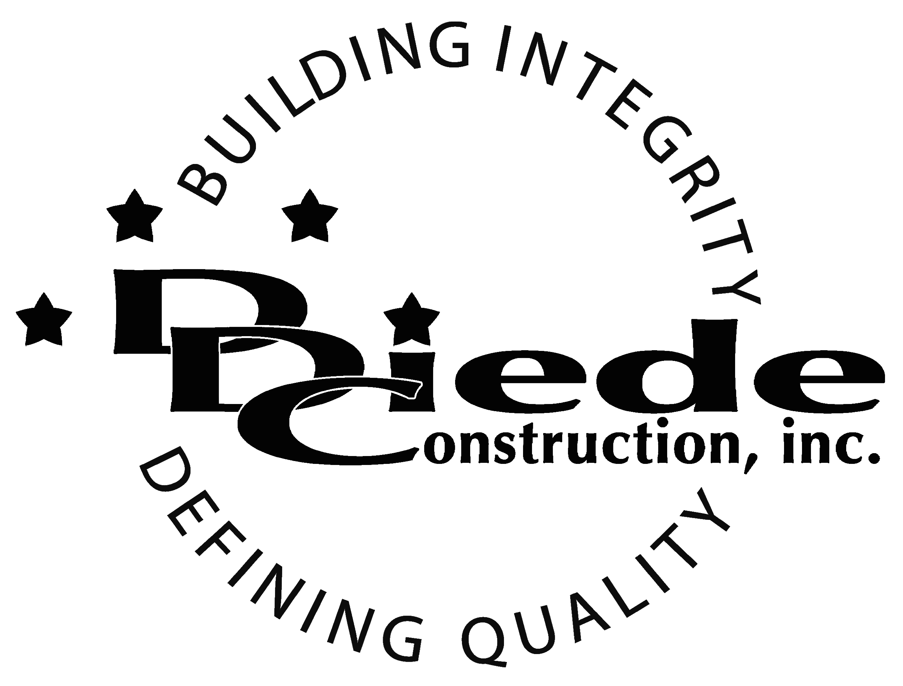
Diede Construction, Inc. Written 10/02/2017
Page 1 of 2

Title: Construction Estimator
Company: Diede Construction, Inc.
Locations: Lodi
Description:
Construction Estimator

Position Summary

The Estimator of Diede Construction, Inc. has the responsibility of ensuring they are familiar with the projects that are bidding and getting the necessary information from subcontractors for those projects to ensure that bid proposals are turned in timely, correct and complete.

The Estimator coordinates with the Sales Department and collect and studies information to control costs and provide accurate projections.

The Estimator is in contact with owners, customers, and subcontractors, which requires tact, sensitivity, and professionalism.

Essential Functions
- Responsible for all aspects of Estimating, including but not limited to:
        - Understand the requirements of each specific project or program.
        - Reviewing plans and specs
        - Preparing Takeoffs
        - Building relationships with Subcontractors
        - Requesting and reviewing Subcontractor quotes
        - Procuring and qualifying bid documents from multiple sources
        - Visiting sites and venues to gather information essential to the project
  - Perform risk analysis
  - Prepare detailed reports or bids for submission to appropriate parties
- Be prepared to bid multiple projects per week
- Ensuring that all questions, concerns or comments regarding sub quotes are answered ahead of bid time and ready for bid
- Communicate with:
        - Owners
        - Owners Reps
        - Suppliers
        - Subcontractors
- The responsibilities of this position include, but are not limited to those listed above.

Knowledge & Skills
- Proficient in using a computer and the below listed programs:
        - Microsoft Office (Outlook, Word, Excel, etc.), Excel knowledge a must
        - Estimating / Takeoff program knowledge
  - Must have strong organization and time management skills, and the ability to self-motivate.
  - Ability to multi-task and manage multiple projects under time constraints and working effectively as a team player in a professional office environment.
  - Demonstrates excellent verbal and written communication skills.
  - Ability to perform duties in a professional manner and appearance.
  - Tactful, professional demeanor with the ability to interact effectively with managers, employees, vendors and others.
  - Excellent plan reading skills
  - Thorough understanding of Specification books a must
  - Must have Construction knowledge
  - Certified Professional Estimator or other qualification a plus
  - Minimum 3 years’ experience working in the construction field in a similar or related position

Company Overview
Family-owned Diede Construction, Inc. (DDC) has grown its reputation by building with integrity since 1978. Today we design, build and manage properties throughout Northern California. The company continues to grow based on our ability to handle larger, more complex projects – projects requiring our signature creativity and our comprehensive services.
We build great buildings not by being big, but by thinking big. We build trust by treating our clients, employees and subcontractors like members of the Diede Family. We expedite projects by having a positive, focused attitude.

