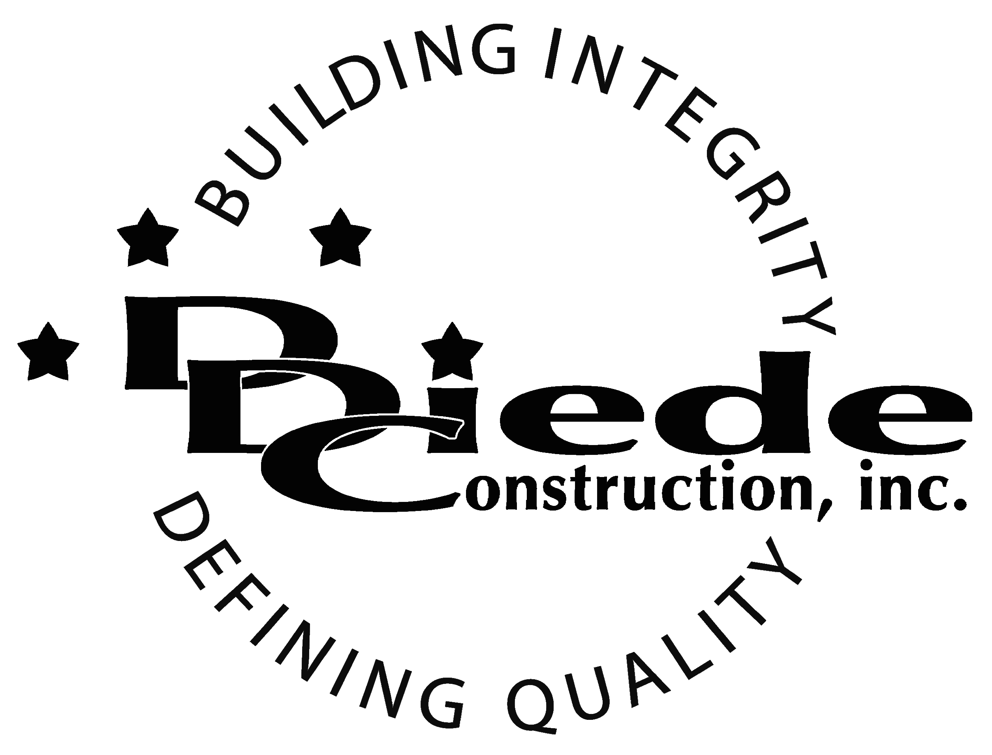
Diede Construction, Inc. Written 10/11/2017
Page 1 of 2

Title: Executive Assistant
Company: Diede Construction, Inc.
Locations: Honolulu, HI
Description:
Executive Assistant

Position Summary

The Executive Assistant for Diede Construction, Inc. performs clerical, secretarial and administrative work in a fast-paced general contracting construction company.

The primary focus of this position will be to assist the executive staff at the office. The executive assistant will handle all administrative duties within the office and legal department.

Essential Functions
- Perform administrative duties for executive management including:
  - Screening Calls
  - Managing Calendars
  - Making travel, meeting and event arrangements
  - Customer Relations
- Assist with accounting tasks such as reimbursements, accounts payable and warranties.
- Run Errands when necessary
- Construction Legal filing
- Heavy document management including filing and scanning.
- Assist with the Bid process
  - Help determine scopes of work
  - Provide assistance with all estimates
  - Bid multiple projects per week
- Assist staff with specific requests or direct them to the proper person or department
- Project Team Administration, including but not limited to:
  - Creating Job Binders
  - Maintaining Project Files
  - Updating PC Lists
  - Miscellaneous Filing
- Communicate with:
  - Owners
  - Owner Reps
  - Clients
  - Architects
  - Subcontractors
- The responsibilities of this position include, but are not limited to those listed above.

Knowledge & Skills
- Proficient in using a computer and the below listed programs:
        - Microsoft Office (Outlook, Word, Excel, etc.)
- Basic knowledge of construction
- Experience assisting Senior Level management
- Detail oriented approach to problem solving.
- Strong organization and time management skills and the ability to prioritize tasks and self-motivate.
  - Ability to multi-task under time constraints and work effectively as a team player in a professional office environment.
  - Demonstrate excellent listening, verbal and written communication skills.
  - Able to perform duties in a professional manner and maintain a professional demeanor under pressure.
  - Tactful, professional demeanor with the ability to interact effectively with owners, managers, employees, vendors, subcontractors, and others.
  - 3 Years administrative experience, preferably in a construction environment.
  - Familiarity with job bidding process preferable.

Company Overview
Family-owned Diede Construction, Inc. (DDC) has grown its reputation by building with integrity since 1978. Today we design, build and manage properties throughout Northern California. The company continues to grow based on our ability to handle larger, more complex projects – projects requiring our signature creativity and our comprehensive services.
We build great buildings not by being big, but by thinking big. We build trust by treating our clients, employees and subcontractors like members of the Diede Family. We expedite projects by having a positive, focused attitude.

