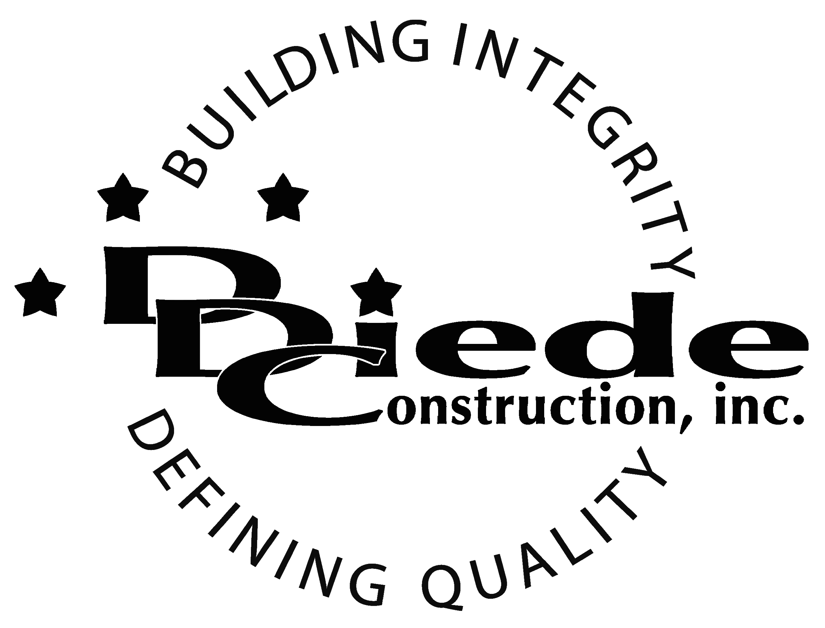
Diede Construction, Inc. Written 11/27/2017
Page 1 of 2

Title: Fleet & Maintenance Manager
Company: Diede Construction, Inc.
Locations: Lodi
Description:
Fleet & Maintenance Manager

Position Summary

The Shop Manager supervises the regular maintenance, diagnosing and repairing of all Diede Construction, Inc. vehicles and equipment. The shop manager is also in charge of tracking the location of any equipment on jobsites and the procurement, maintenance, upkeep, and return of rental equipment necessary on jobsites.

The Shop Manager of Diede Construction, Inc. directly supervises maintenance employees and carries out supervisory responsibilities in accordance with the Company’s policies and applicable Federal and State laws.

The Shop Manager is in direct contact and must be able to establish good relationships with Public Agency Officials, Employees, Vendors and the General Public which requires tact, sensitivity and professionalism.

Essential Functions
- Responsible for all tracking, maintenance and repairs of company equipment including but not limited to:
        - Communicating with vendors to ensure timely repair and delivery of parts and equipment
        - Coordinating a variety of projects and activities to assure the delivery of service and equipment within established guidelines.
        - Managing the day to day operations of the Shop; supervises the diagnosing and repair of all vehicles owned by Diede Construction, Inc.
        - Responding to safety and/or operational concerns and takes appropriate action to resolve immediate safety issues and to help maintain a safe, functioning jobsite.
        - Responding to calls regarding disabled vehicles or equipment for the purpose of performing or dispatching outside vendors to perform emergency repair work in the field.
        - Supervising assigned staff to ensure work assignments are complete and within department objectives.
- Conducts regularly scheduled safety and department meetings
- Procures, tracks, and arranges for the return of rental equipment as requested by Project Managers and Superintendents
- Collaborate with field personnel (Super’s & Foremen)
- Communicate with:
        - Supervisors & Foremen
        - Suppliers
        - Subcontractors
- Provide day to day guidance to staff in the performance of their duties
- Managing and tracking expenses in relation to department budget.
- Working with the Corporate Safety Manager to respond to requests from government regulatory and/or other governmental agencies
- Maintains manual and electronic files and records to provide up to date information on equipment and comply with regulatory requirements
- The responsibilities of this position include, but are not limited to those listed above.

Knowledge & Skills
- Must have strong problem-solving abilities.
- Knowledge of automotive repair and vehicle mechanics
- Knowledge of inventory control
- Operating standard office equipment
- Proficient in using a computer and the below listed programs:
        - Microsoft Office (Outlook, Word, Excel, etc.)
  - Must have strong organization and time management skills, and the ability to self-motivate.
  - Ability to multi-task under time constraints and working effectively as a team
  - Demonstrates excellent verbal and written communication skills.
  - Tactful, professional demeanor with the ability to interact effectively with managers, employees, vendors and others.
  - Must be able to effectively supervise and manage multiple reports and objectively appraise their performance while addressing complaints and resolving problems.
  - Experience with budgeting and contracts.

Company Overview
Family-owned Diede Construction, Inc. (DDC) has grown its reputation by building with integrity since 1978. Today we design, build and manage properties throughout Northern California. The company continues to grow based on our ability to handle larger, more complex projects – projects requiring our signature creativity and our comprehensive services.
We build great buildings not by being big, but by thinking big. We build trust by treating our clients, employees and subcontractors like members of the Diede Family. We expedite projects by having a positive, focused attitude.

