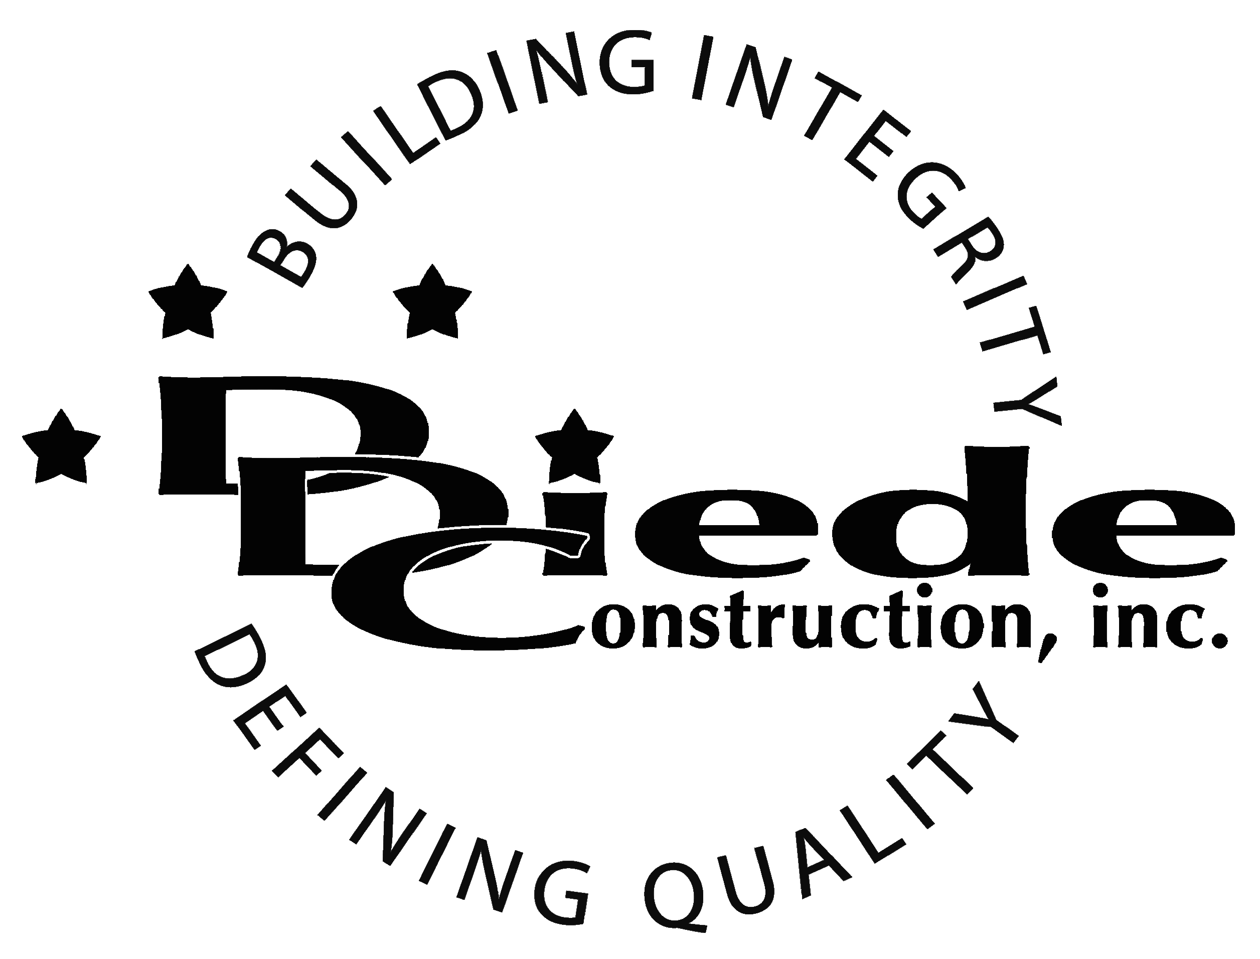
Diede Construction, Inc. Written 09/16/2016
Page 1 of 2

Title: General Manager – Residential Construction
Company: Diede Construction, Inc.
Locations: Lodi
Description:
General Manager – Residential Construction

Position Summary

The General Manager provides leadership on their project and is responsible for the overall field supervision of the residential construction project.

The General Manager of Residential Construction has the responsibility to work closely with the Project Management team to ensure the success of the project.

The General Manager is in contact with DDC personnel, owners, customers, subcontractors, inspectors, and city officials, which requires tact, sensitivity, and professionalism.

Essential Functions
- Ability to read project plans and understanding of project documents to estimate constructability, develop scope of work, insure accuracy, and assess risk.
- Responsible for all day to day operations on the project site including but not limited to:
        - Scheduling subcontractors
        - Scheduling DDC personnel
        - Ordering Material
        - Troubleshooting
        - Paperwork including cost tracking and other reports
- Walk and inspect construction site daily to verify compliance with company and OSHA safety requirements.
- Material takeoffs
- Communicate with:
        - Owners
        - Owners Reps
        - Suppliers
        - Subcontractors
        - City officials
        - Inspectors
        - DDC Personnel
- Complete knowledge of subcontracts
- The responsibilities of this position include, but are not limited to those listed above.
- Willingness to travel
Knowledge & Skills
- Proficient in using a computer and the below listed programs:
        - Microsoft Office (Outlook, Word, Excel, etc.)
        - P6 knowledge preferred
  - Must have strong organization and time management skills.
  - Ability to multi-task under time constraints and work effectively as a team player.
  - Demonstrates excellent verbal and written communication skills.
  - Ability to perform duties in a professional manner and appearance.
  - Tactful, professional demeanor with the ability to interact effectively with managers, employees, vendors and others.
  - Ability to read plans.
  - Ability to encourage and motivate your construction team.
  - Knowledge of residential building code requirements and scheduling methods
  - Knowledge of state regulations including safety, storm water runoff, etc.
Company Overview
Family-owned Diede Construction, Inc. (DDC) has grown its reputation by building with integrity since 1978. Today we design, build and manage properties throughout several surrounding states. The company continues to grow based on our ability to handle larger, more complex projects – projects requiring our signature creativity and our comprehensive services.
We build great buildings not by being big, but by thinking big. We build trust by treating our clients, employees and subcontractors like members of the Diede Family. We expedite projects by having a positive, focused attitude.

