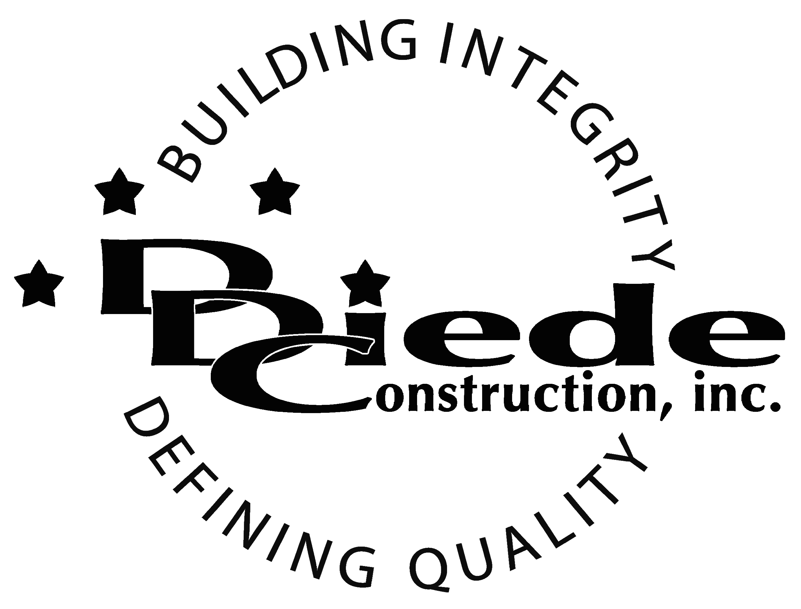
Diede Construction, Inc. Written 09/14/2017
Page 1 of 2

Title: Human Resources
Company: Diede Companies, Inc.
Locations: Lodi
Description:
Human Resources

Position Summary

The Human Resources Professional oversees Human Resources activities to support business growth.

This individual will also assure legal compliance in all personnel issues including staffing, corrective action, terminations, benefit administration, etc.

The Human Resources Professional will also promote and implement best practices in various departments and topics company wide.

Essential Functions
- Develop, implement and administer internal policies and procedures.
- Assure legal compliance of company policy and procedure; consult with outside experts or counsel when appropriate.
- Manage employment activities relating to recruitment, retention and separations.
- Manage onboarding of all new employees:
  - New Hire Orientation
  - Completion of new hire packet and entering data into HRIS
  - Coordinate resources for employee’s first day
- Oversee the performance management process including:
  - Annual evaluations
  - Guidelines for establishment of employee’s annual goals and objectives
  - Guidelines for performance remediation and enhancement
- Support managers in disciplinary activities as well as rewards and recognition
- Manage compensation programs, including job descriptions and market analysis. Establish base pay ranges and work with the Senior Operations Management Team to formulate any variable pay programs.
- Liaise with Benefit Plan brokers and carriers; may serve as plan administrator for certain benefit plans.
- Employee relation activities, including grievance resolution, investigations and leaves of absence.
- Use existing files and other resources to develop information for pending legal proceedings.
- Document management including filing and scanning. Assure integrity of all employee files and information.
- Assist staff with specific requests or direct them to the proper person or department
- Stay up to date and brief operations management team on legal issues affecting the company.
- Report on all HR activities and trends to executive management, both formally and informally.
- Work with the Director of Safety to manage workers compensation claims and administration.
- Time off scheduling; assure the company is appropriately staffed at all times.
- Employee event planning and coordination.
- The responsibilities of this position include, but are not limited to those listed above.

Knowledge & Skills
- Proficient in using a computer and the below listed programs:
        - Microsoft Office (Outlook, Word, Excel, etc.)
        - Adobe Acrobat
- Detail oriented approach to problem solving.
- Strong organization and time management skills and the ability to prioritize tasks and self-motivate.
  - Ability to multi-task under time constraints and work effectively as a team player in a professional office environment.
  - Demonstrate excellent listening, verbal and written communication skills.
  - Able to perform duties in a professional manner and maintain a professional demeanor under pressure.
  - Tactful, professional demeanor with the ability to interact effectively with owners, managers, employees, vendors, subcontractors, and others.
  - AA Certificate in Human Resource Management (Bachelor’s Degree preferred)
  - 5 years’ experience in a professional capacity (10 years preferred)
  - Administrative experience in a construction or manufacturing environment.
  - Familiarity with Prevailing Wage and Payroll Processing.

Company Overview
Family-owned Diede Companies, Inc. has grown its reputation by building with integrity since 1978. Today we design, build and manage properties throughout Northern California. The company continues to grow based on our ability to handle larger, more complex projects – projects requiring our signature creativity and our comprehensive services.
We build great buildings not by being big, but by thinking big. We build trust by treating our clients, employees and subcontractors like members of the Diede Family. We expedite projects by having a positive, focused attitude.

