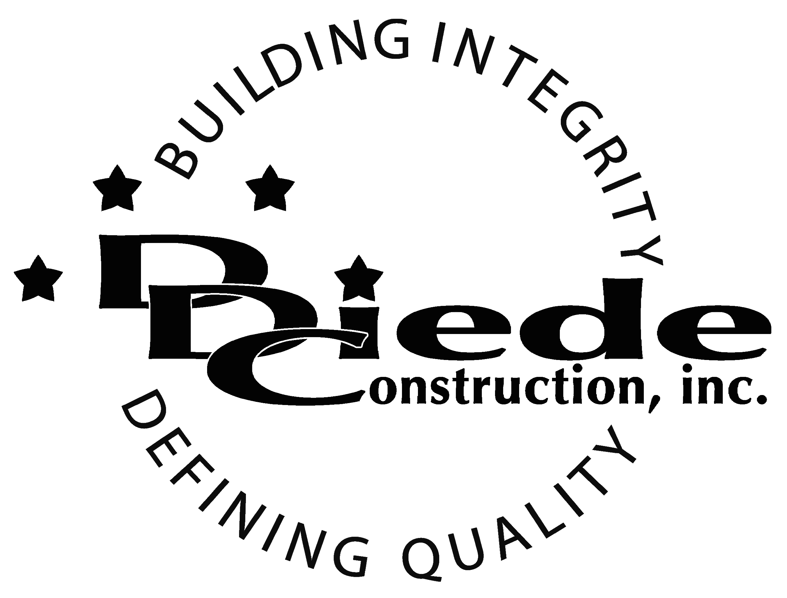
Diede Construction, Inc. Written 08/28/2017
Page 1 of 2

Title: Legal Secretary
Company: Diede Companies, Inc.
Locations: Lodi
Description:
Legal Secretary

Position Summary

The Legal Secretary for Diede Companies, Inc. performs clerical, secretarial and administrative work in a fast-paced general contracting construction company.

The primary focus of this position will be to exclusively assist the operations management team at the office. The Legal Secretary will handle all administrative duties within the legal department.

Essential Functions
- Perform administrative duties for the legal department including:
  - Screening Calls
  - Manage Calendars
  - Writing Legal Documents
  - Conducting Research relating to existing legal issues
  - Create legal files
- Document Management for all Properties including Compliance, Certificate of Insurance, Invoices, Lien Waivers, Work Orders, End of Year Tax documents, etc.
- Run Errands when necessary
- Construction Legal filing
- Heavy document management including filing and scanning.
- Assist the operations team as needed
- Assist staff with specific requests or direct them to the proper person or department
- Complete other administrative tasks as requested
- Communicate with:
        - Owners
        - Owner Reps
        - Clients
        - Attorneys
        - Subcontractors
- The responsibilities of this position include, but are not limited to those listed above.

Knowledge & Skills
- Proficient in using a computer and the below listed programs:
        - Microsoft Office (Outlook, Word, Excel, etc.)
        - Adobe Acrobat
- Basic knowledge of construction
- Experience assisting Senior Level management

- Detail oriented approach to problem solving.
- Strong organization and time management skills and the ability to prioritize tasks and self-motivate.
  - Ability to multi-task under time constraints and work effectively as a team player in a professional office environment.
  - Demonstrate excellent listening, verbal and written communication skills.
  - Able to perform duties in a professional manner and maintain a professional demeanor under pressure.
  - Tactful, professional demeanor with the ability to interact effectively with owners, managers, employees, vendors, subcontractors, and others.
  - 3 Years administrative experience.
  - Administrative experience in a construction or manufacturing environment.

Company Overview
Family-owned Diede Companies, Inc. (DDC) has grown its reputation by building with integrity since 1978. Today we design, build and manage properties throughout Northern California. The company continues to grow based on our ability to handle larger, more complex projects – projects requiring our signature creativity and our comprehensive services.
We build great buildings not by being big, but by thinking big. We build trust by treating our clients, employees and subcontractors like members of the Diede Family. We expedite projects by having a positive, focused attitude.

