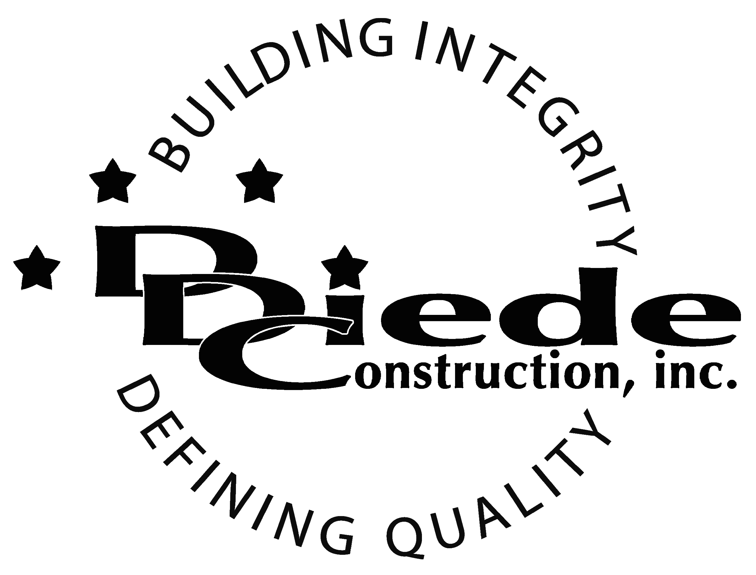
Diede Construction, Inc. Written 10/4/2017
Page 1 of 2

Title: Office Manager
Company: Diede Companies, Inc.
Locations: Lodi
Description:
Office Manager

Position Summary

The Office Manager is responsible for supporting company operations by maintaining office systems and supervising staff.

This individual will also be responsible for directing and coordinating office services and related activities, including developing and supervising programs for the maximum utilization of services and equipment.

The Office Manager will also be responsible for developing communication protocols, streamlining administrative procedures, office inventory control, and overall office operations.

Essential Functions
- Develop, implement and administer internal policies and procedures relating to administrative duties, filing systems, office equipment and supply procurement.
- Assure supplies and office equipment are ordered and ready to be dispatched as needed.
- Manage office facilities and be the point of contact for IT support.
- Supervise the maintenance and alteration of office areas and equipment, as well as layout, arrangement and housekeeping of office facilities.
- Responsible for facility day to day operations including maintenance, access and security.
- Manage employee schedules and troubleshoot scheduling conflicts as they arise.
- Assure legal compliance of company policy and procedure; consult with outside experts or counsel when appropriate.
- Oversee Document management, including filing and scanning. Assure the integrity of all legal files and information.
- Support managers in disciplinary activities as well as rewards and recognition
- Use existing files and other resources to develop information for pending legal proceedings.
- Assist staff with specific requests or direct them to the proper person or department
- Stay up to date and brief management team on legal issues affecting the company.
- The responsibilities of this position include, but are not limited to those listed above.

Knowledge & Skills
- Proficient in using a computer and the below listed programs:
        - Microsoft Office (Outlook, Word, Excel, etc.)
        - Adobe Acrobat
- Detail oriented approach to problem solving.
- Strong organization and time management skills and the ability to prioritize tasks and self-motivate.
  - Ability to multi-task under time constraints and work effectively as a team player in a fast paced professional office environment.

  - Demonstrate excellent listening, verbal and written communication skills.
  - Able to perform duties in a professional manner and maintain a professional demeanor under pressure.
  - Tactful, professional demeanor with the ability to interact effectively with owners, managers, employees, vendors, subcontractors, and others.
  - AA Degre (Bachelor’s Degree preferred)
  - 3 years’ experience in a professional capacity (5 years preferred)
  - Administrative experience in a construction environment.
  - Supply management experience

Company Overview
Family-owned Diede Companies, Inc. (DDC) has grown its reputation by building with integrity since 1978. Today we design, build and manage properties throughout Northern California. The company continues to grow based on our ability to handle larger, more complex projects – projects requiring our signature creativity and our comprehensive services.
We build great buildings not by being big, but by thinking big. We build trust by treating our clients, employees and subcontractors like members of the Diede Family. We expedite projects by having a positive, focused attitude.

