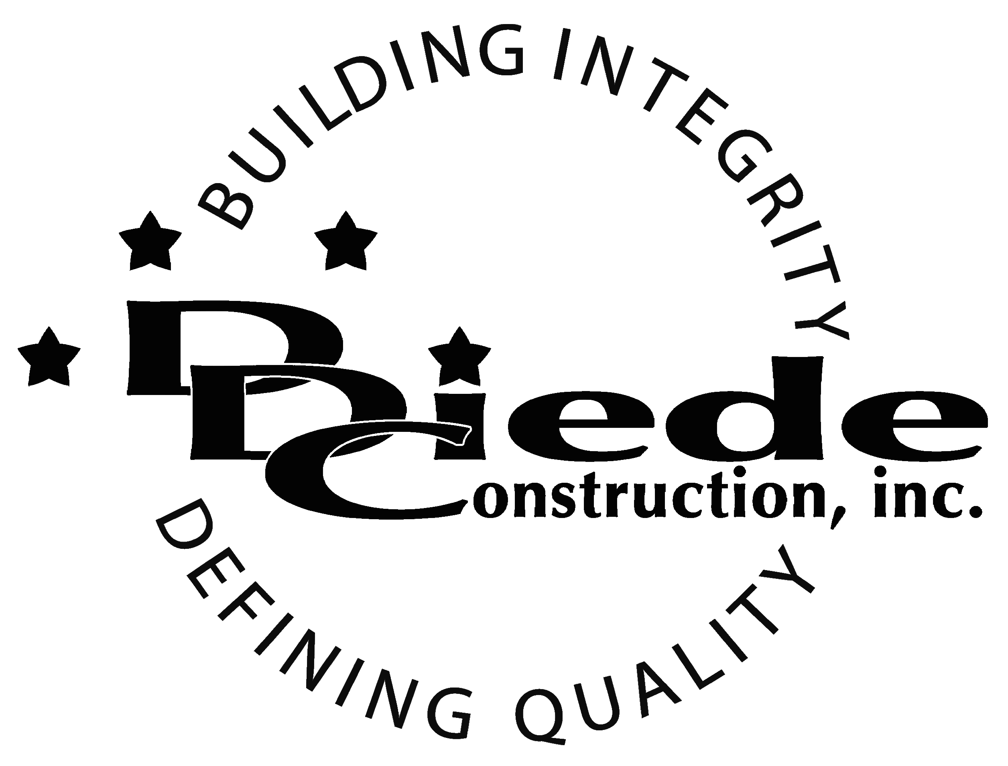
Diede Construction, Inc. Written 10/4/2017
Page 1 of 2

Title: Operations Manager
Company: Diede Companies, Inc.
Locations: Lodi
Description:
Operations Manager

Position Summary

The Operations Manager is responsible for the coordination, implementation, execution, control and completion of active construction projects.

This position will oversee all Project Teams and use technical and practical expertise to ensure projects are completed in a timely manner and within budget. The Operations Manager will work with Project Managers to make sure resources are allocated in an efficient manner.

The Operations Manager will develop new procedures, standardize Project Team processes, and promote staff development and training.

Essential Functions
- Manages the company Project teams and all related support departments.
- Ensures that all projects are operated and maintained in a cost-effective manner and stay within budget.
- Coordinate with owners, PM’s and any additional stakeholders or outside resources regarding contractual issues. Review and interpret contract Terms and Conditions, escalating issues as necessary.
- Meets with clients to explain technical information and solve issues with them as needed.
- Works with the Estimating department to make sure all specifications of the project are included when it is handed off to the Project Team.
- Manages any contractor problems, performance or administration.
- Assigns projects to different teams based on workload, expertise and available resources.
- Makes sure projects are completed according to specifications and schedule.
- Maintains, develops and enhances the company’s relationship with contractors in order to produce strategic partnerships.
- Trains and mentors employees in areas of project management and estimating.

Knowledge & Skills
- Proficient in using a computer and the below listed programs:
        - Microsoft Office (Outlook, Word, Excel, etc.)
        - Adobe Acrobat
- Detail oriented approach to problem solving.
- Strong organization and time management skills and the ability to prioritize tasks and self-motivate.
  - Ability to multi-task under time constraints and work effectively as a team player in a fast paced professional office environment.

  - Demonstrate excellent listening, verbal and written communication skills.
  - Able to perform duties in a professional manner and maintain a professional demeanor under pressure.
  - Tactful, professional demeanor with the ability to interact effectively with owners, managers, employees, vendors, subcontractors, and others.
  - Ability to maintain composure and objectivity in difficult situations and resolve conflict without escalating tensions.
  - Bachelor’s Degree in Engineering, Construction Management or the equivalent combination of technical training and related experience.
  - Minimum 5 years’ experience managing in a professional capacity
  - Experience in a construction company.
  - Knowledge and understanding of construction drawings, specifications, schedules, means and methods.
  - Supply management experience

Company Overview
Family-owned Diede Companies, Inc. (DDC) has grown its reputation by building with integrity since 1978. Today we design, build and manage properties throughout Northern California. The company continues to grow based on our ability to handle larger, more complex projects – projects requiring our signature creativity and our comprehensive services.
We build great buildings not by being big, but by thinking big. We build trust by treating our clients, employees and subcontractors like members of the Diede Family. We expedite projects by having a positive, focused attitude.

