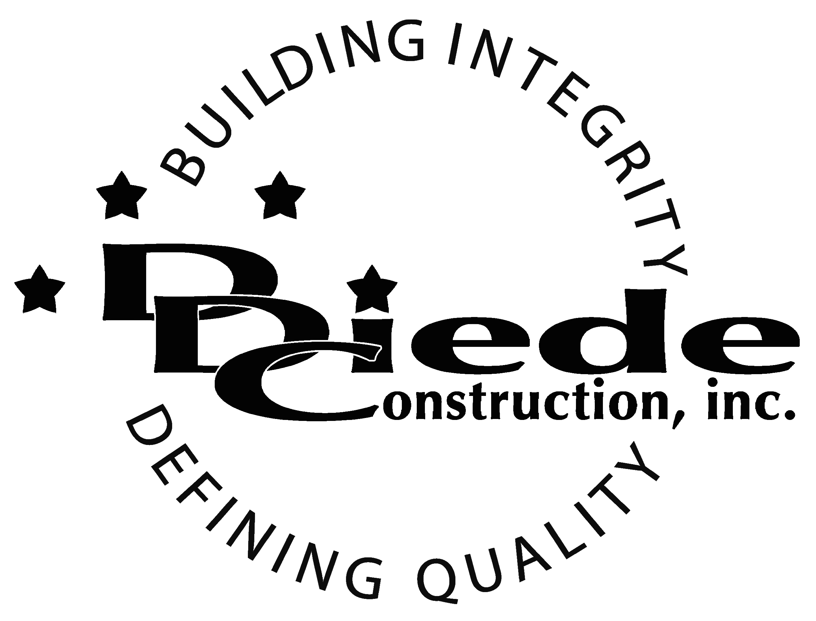
Diede Construction, Inc. Written 10/02/2017
Page 1 of 2

Title: Payroll Administrator
Company: Diede Construction, Inc.
Locations: Lodi
Description:
Payroll Administrator

Position Summary

The payroll Administrator is responsible for coordinating and processing weekly, multi state payroll while ensuring compliance with local, state, and federal payroll tax laws and regulations.

The payroll administrator works closely with the Operations, Labor Compliance and Human Resources departments to ensure data is accurate and submitted to appropriate parties in a timely manner.

Essential Functions
- Responsible for the preparation and processing of weekly payroll for Exempt and Non-Exempt employees
        - Ensure accuracy of approved Timesheets and timecards
        - Make sure payroll is applied to appropriate projects
        - Track and deduct all garnishments
        - Track and deduct any other payroll deductions
- Ensure proper flow and maintenance of employee data by coordinating between Operations, Labor Compliance and Human Resources
        - Maintain reports to correctly record employee medical, pension and 401k contributions
- Print and prepare manual checks and deposit statements for distribution to employees
- Post payroll and process weekly State and Federal taxes
- Work with employees and management to resolve any payroll related issues
- Submit Benefits Enrollment/changes and payroll changes in an accurate, timely manner
- Address any employee complaints, questions and concerns about payroll services and communicate any issues to the appropriate parties
- Maintain policies and procedures for processing payroll which comply with all federal, state and local regulations
- Keep management informed of any current issues and upcoming changes in legislation that affect the company
- The responsibilities of this position include, but are not limited to those listed above.

Knowledge & Skills
- Proficient in using a computer and the below listed programs:
        - Microsoft Office (Outlook, Word, Excel, etc.)
        - Vista by Viewpoint or other construction software
        - Knowledge of DIR website and eCPR
  - Must have strong organization and time management skills, and the ability to self-motivate.
  - Good math and accounting skills
  - Ability to multi-task under time constraints and working effectively as a team player in a professional office environment.
  - Demonstrates excellent verbal and written communication skills.
  - Ability to perform duties in a professional manner and appearance.

  - Tactful, professional demeanor with the ability to interact effectively with managers, employees, vendors and others.
  - Construction industry experience
  - Knowledge of Public Works law and labor codes

Company Overview
Family-owned Diede Construction, Inc. (DDC) has grown its reputation by building with integrity since 1978. Today we design, build and manage properties throughout Northern California. The company continues to grow based on our ability to handle larger, more complex projects – projects requiring our signature creativity and our comprehensive services.
We build great buildings not by being big, but by thinking big. We build trust by treating our clients, employees and subcontractors like members of the Diede Family. We expedite projects by having a positive, focused attitude.

