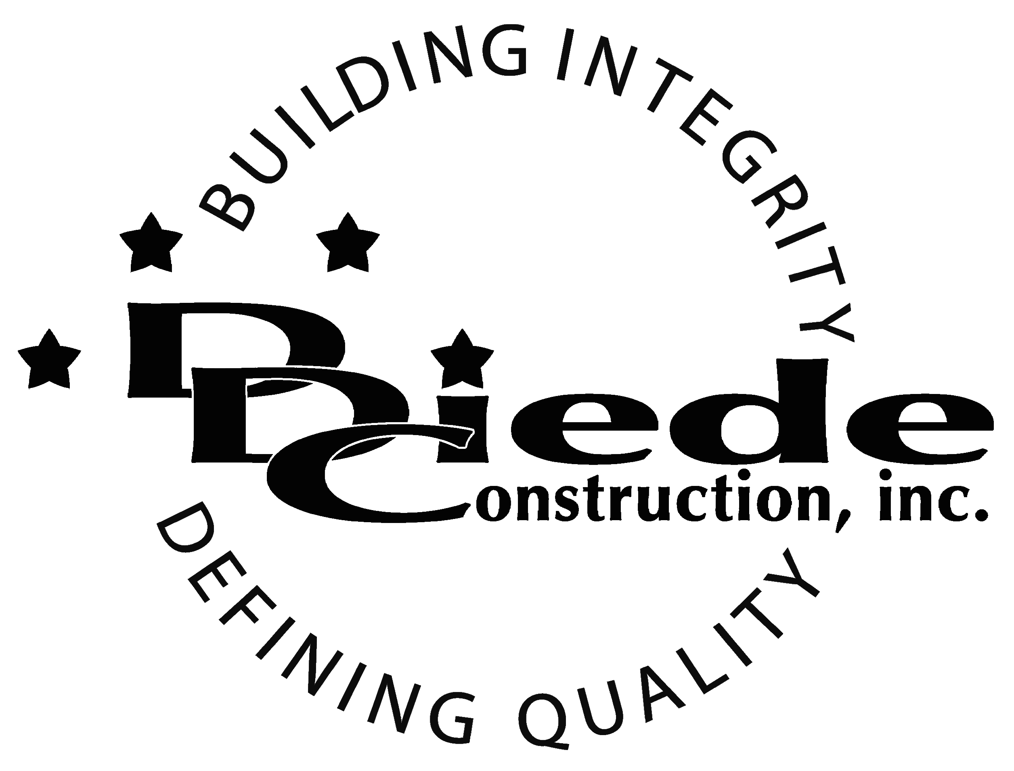
Diede Construction, Inc. Written 10/25/2016
Page 1 of 2

Title: Construction Project Coordinator
Company: Diede Construction, Inc.
Locations: Lodi
Description:
Construction Project Coordinator

Position Summary

The Project Coordinator provides overall administrative and construction support for multiple projects for our Project Management Teams.

The Project Coordinator of Diede Construction, Inc. has the responsibility for working closely with the Project Team in providing documentation and administrative support for projects.

The Project Coordinator is in contact with owners, customers, and subcontractors, which requires tact, sensitivity, and professionalism.

Essential Functions
- Responsible for project administration for their team, including but not limited to:
        - Creating Job Binders
        - Maintaining Project Files
        - Updating PC List
        - Miscellaneous Filing
- Communicate with:
        - Owners
        - Owners Reps
        - Suppliers
        - Subcontractors
- Support Project Manager in Assistant Project Manager’s absence.
- The responsibilities of this position include, but are not limited to those listed above.
Knowledge & Skills
- Proficient in using a computer and the below listed programs:
        - Microsoft Office (Outlook, Word, Excel, etc.)
        - P6 knowledge preferred
  - Must have strong organization and time management skills, and the ability to self-motivate.
  - Ability to multi-task under time constraints and working effectively as a team player in a professional office environment.
  - Demonstrates excellent verbal and written communication skills.
  - Ability to perform duties in a professional manner and appearance.
  - Tactful, professional demeanor with the ability to interact effectively with managers, employees, vendors and others.

Company Overview
Family-owned Diede Construction, Inc. (DDC) has grown its reputation by building with integrity since 1978. Today we design, build and manage properties throughout Northern California. The company continues to grow based on our ability to handle larger, more complex projects – projects requiring our signature creativity and our comprehensive services.
We build great buildings not by being big, but by thinking big. We build trust by treating our clients, employees and subcontractors like members of the Diede Family. We expedite projects by having a positive, focused attitude.

