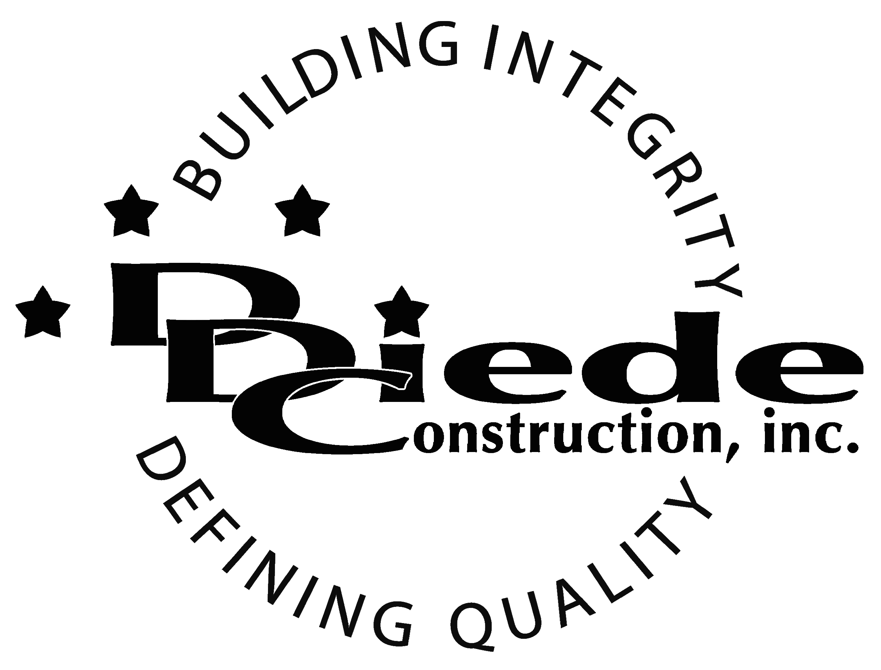
Diede Construction, Inc. Written 07/27/2016
Page 1 of 2

Title: Construction Project Manager
Company: Diede Construction, Inc.
Locations: Lodi
Description:
Project Manager

Position Summary

The Construction Project Manager plans, directs, and coordinates activities of multiple projects to ensure that the established objectives are accomplished within the prescribed time frame and budget.

The Construction Project Manager of Diede Construction, Inc. directly supervises multiple employees working on their projects and carries out supervisory responsibilities in accordance with the Company’s policies and applicable Federal and State laws.

The Project Manager is in contact and must be able to establish good relationships with Owners, Customers, Contractors, Design Consultants, Public Agency Officials, Employees and the General Public which requires tact, sensitivity and professionalism.

Essential Functions
- Responsible for all project administration for their team, including but not limited to:
        - Review project proposals or plans to determine time frame, funding limitations, procedures, staffing requirements and allotment of resources to various project phases
        - Closely monitoring budgets to ensure project’s profitability
        - Confer with project staff to outline work plan and assign duties, responsibilities and scope of authority.
        - Oversee consultant’s and owner’s agreements, subcontracts, change orders and other agreements.
        - Preparing RFI’s
        - Preparing Takeoffs
        - Preparing Proposals
- Conduct weekly project meetings
- Collaborate with field personnel (Super’s & Foremen)
- Communicate with:
        - Clients
        - Owners
        - Owners Reps
        - Suppliers
        - Subcontractors
- Provide day to day guidance to technical staff in the performance of their duties
- Coordinate project activities with government regulatory and/or other governmental agencies
- The responsibilities of this position include, but are not limited to those listed above.
Knowledge & Skills
- Proficient in using a computer and the below listed programs:
        - Microsoft Office (Outlook, Word, Excel, etc.)
        - P6 knowledge preferred
  - Must have strong organization and time management skills, and the ability to self-motivate.
  - Ability to multi-task under time constraints and working effectively as a team player in a professional office environment.
  - Demonstrates excellent verbal and written communication skills.
  - Ability to perform duties in a professional manner and appearance.
  - Tactful, professional demeanor with the ability to interact effectively with managers, employees, vendors and others.
  - Must be able to effectively supervise and manage multiple reports and objectively appraise their performance while addressing complaints and resolving problems.
  - Ability to read plans
  - Experience with estimating, budgeting and contracts.

Safety
- Ensure that this is a healthy and accident-free work environment on during the project for direct hire individuals and sub-contractors, alike with the following expectations:

        - Safety goals are achieved on every project
        - No accidents or near misses
        - No OSHA citations.
        - Employees have a positive attitude toward safe work practices
        - Employees are well-educated in safe practices and have all the resources necessary to work safely
        - Observe and practice all governmental safety regulations, project requirements and company safety policies
        - Analyzes and recommends corrective action for all accidents
        - Point of contact for Owner/Client Safety Representatives
        - Post all safety bulletins, safety posters, safety rules, and applicable legislation
        - Coordinate the transportation of injured employees to a physician's office or hospital
        - Maintain relations with project physicians, the workers' compensation case nurse, ambulance service, fire department and hospitals

Company Overview
Family-owned Diede Construction, Inc. (DDC) has grown its reputation by building with integrity since 1978. Today we design, build and manage properties throughout Northern California. The company continues to grow based on our ability to handle larger, more complex projects – projects requiring our signature creativity and our comprehensive services.
We build great buildings not by being big, but by thinking big. We build trust by treating our clients, employees and subcontractors like members of the Diede Family. We expedite projects by having a positive, focused attitude.

