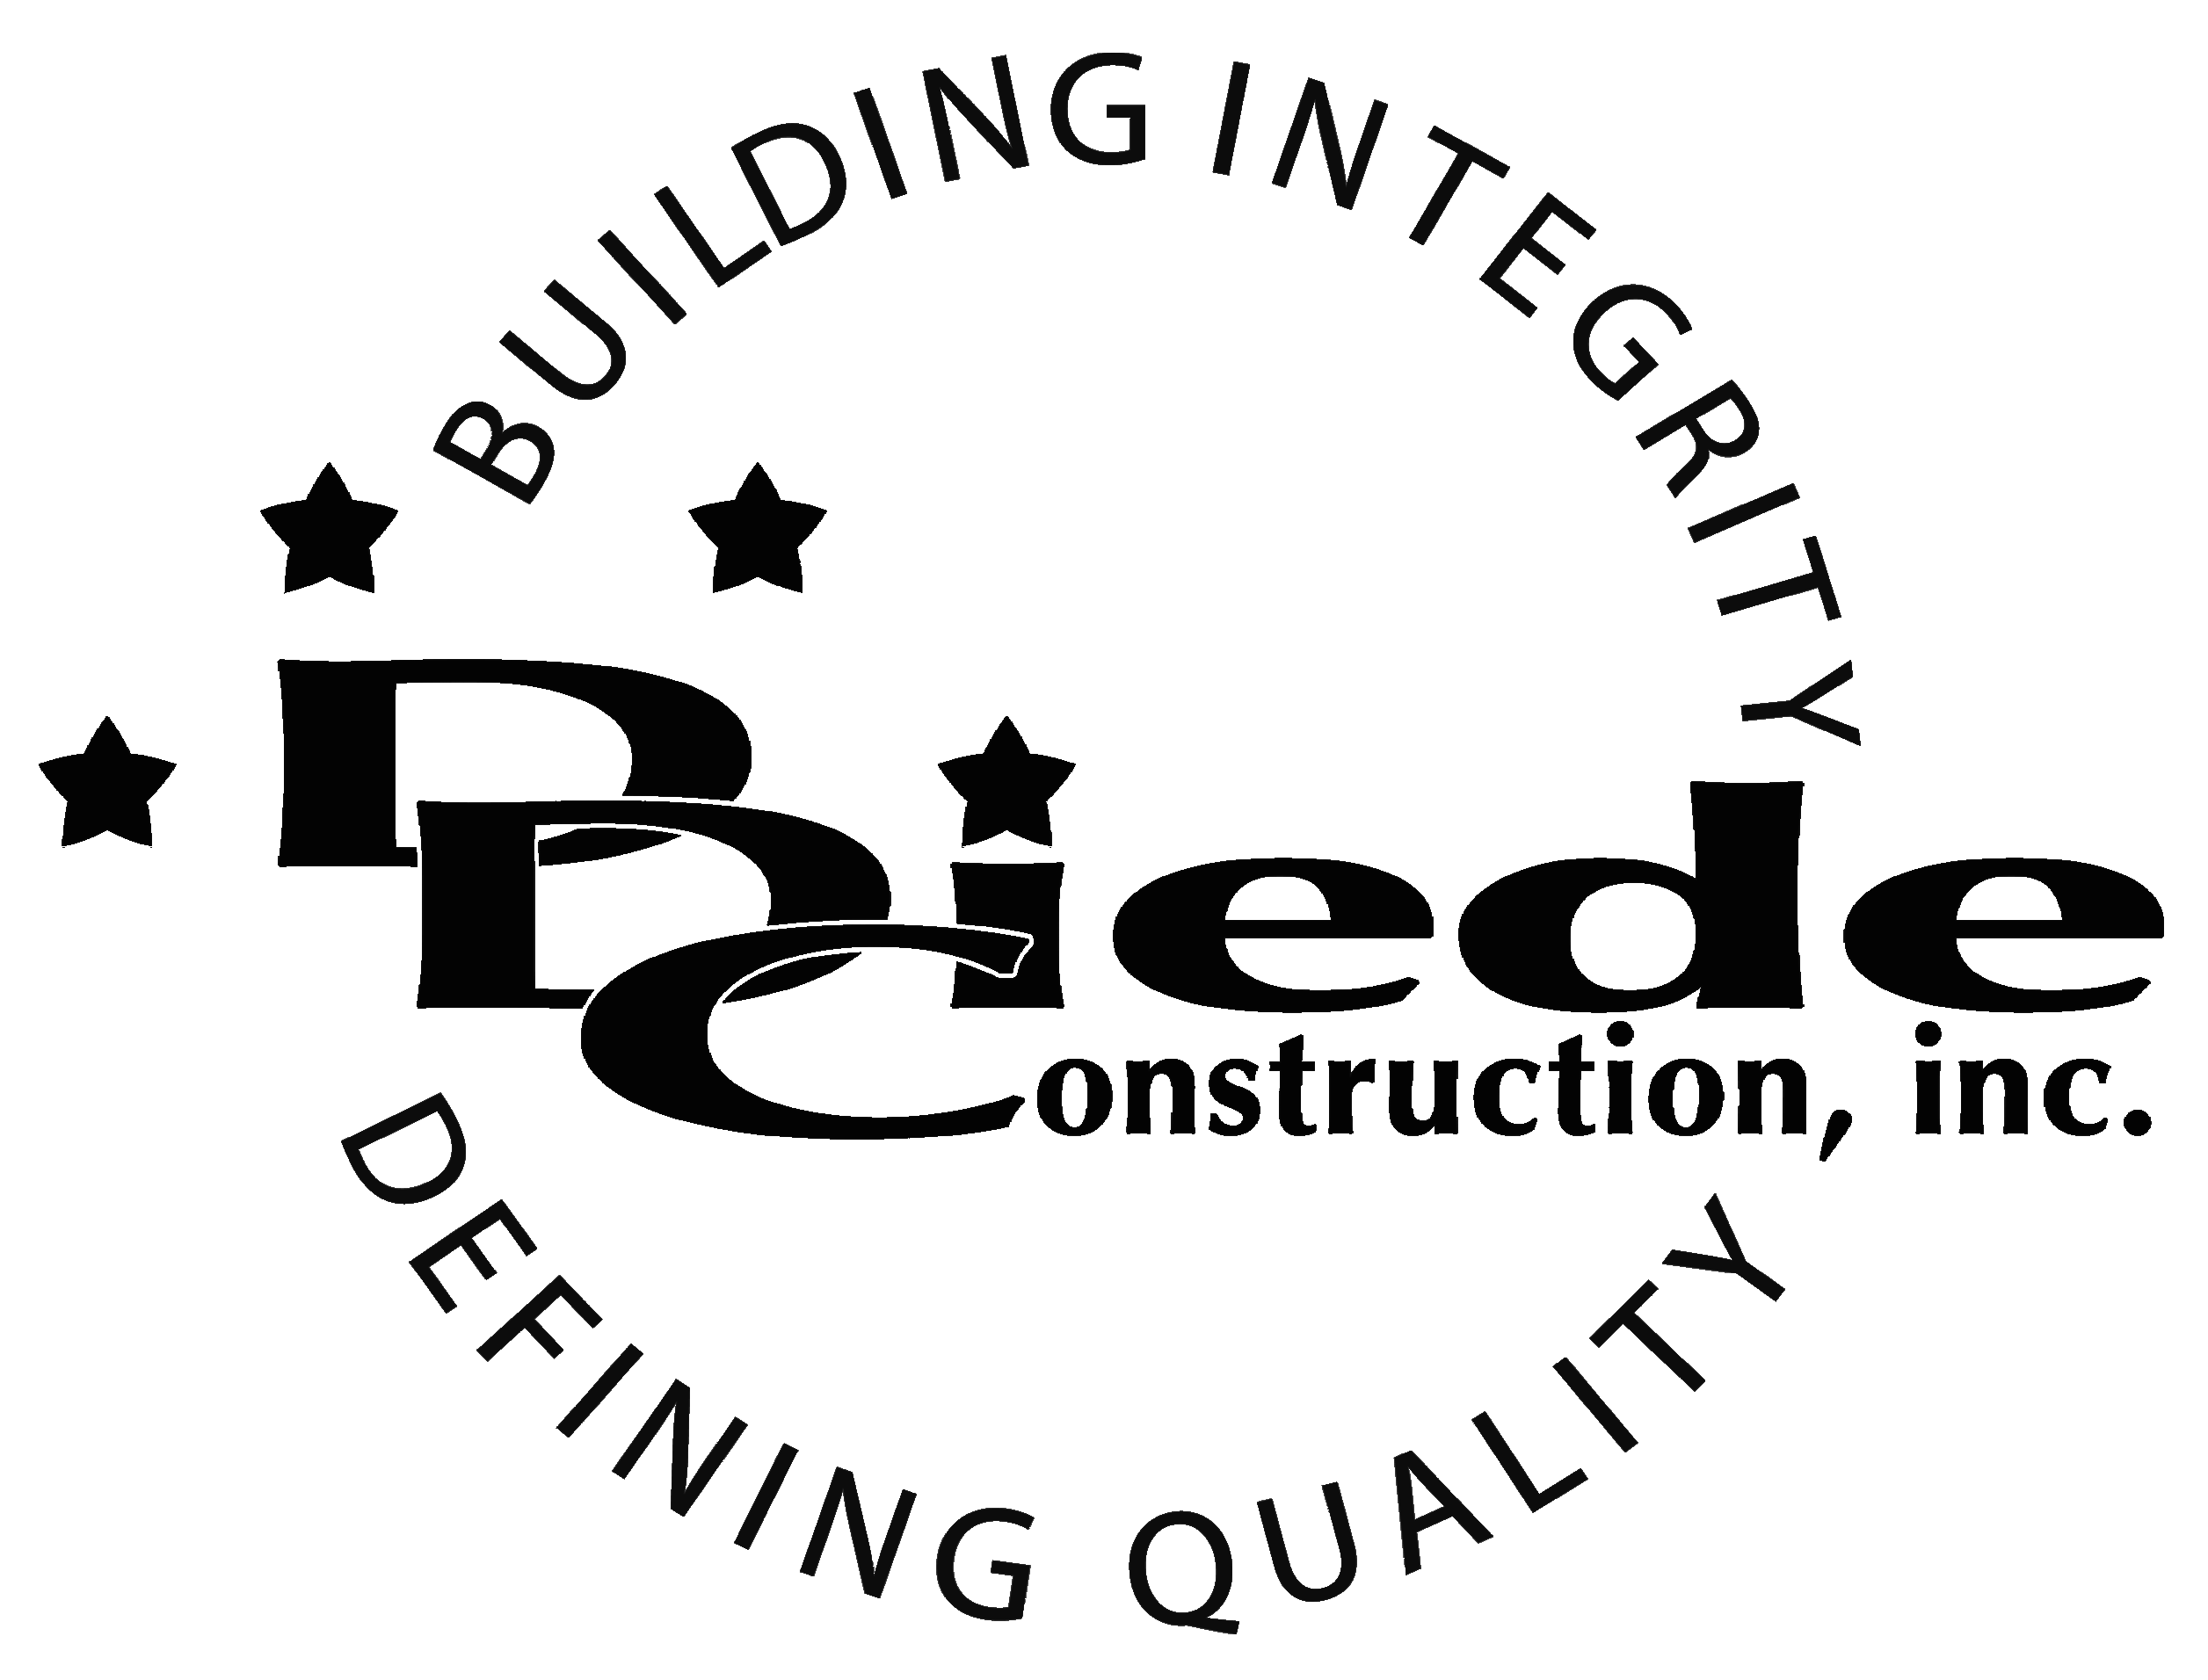
Diede Construction, Inc. Written 09/06/2016
Page 1 of 2

Title: Receptionist
Company: Diede Construction, Inc.
Locations: Lodi
Description:
Receptionist

Position Summary

The Receptionist for Diede Construction, Inc. performs clerical, secretarial and administrative work in a fast-paced general contracting construction company.

The receptionist will be in charge of answering multi-line telephones, faxing, copying, shipping and receiving.

The Receptionist has frequent contact with owners, customers, and subcontractors, which requires tact, sensitivity, and professionalism. The person in this position must be able to work well in a team environment, perform under pressure, and maintain a professional demeanor at all times.

Essential Functions
- Greeting, welcoming guests, customers and employees
- Delivering excellent customer service at all times
- Responsible for managing all front desk duties, including but not limited to:
        - Screening and directing phone calls promptly to the appropriate staff member
        - Greeting visitors and notifying staff members
        - Assisting applicants
        - Help visitors in the plan room and maintain a log
        - Process day to day administrative items: incoming and outgoing mail, packages, checks, etc.
        - Respond to written and electronic correspondence
- Directing IT personnel to the correct offices
- Ensure Lobby, office, plan room and break area are safe, clean and organized
- Coordinate meetings, book conference rooms and manage calendars
- Data entry into various platforms, as needed
- Assist with bids when necessary
- Communicate with:
        - Owners
        - Owner Reps
        - Clients
        - Architects
        - Subcontractors
- The responsibilities of this position include, but are not limited to those listed above.

Knowledge & Skills
- Proficient in using a computer and the below listed programs:
        - Microsoft Office (Outlook, Word, Excel, etc.)
  - Strong organization and time management skills and the ability to self-motivate.
  - Ability to multi-task under time constraints and work effectively as a team player in a professional office environment.
  - Demonstrate excellent listening, verbal and written communication skills.
  - Able to perform duties in a professional manner and maintain a professional demeanor.
  - Tactful, professional demeanor with the ability to interact effectively with managers, employees, vendors and others.
  - Receptionist experience in a construction or manufacturing environment and familiarity with job bidding process preferable.

Company Overview
Family-owned Diede Construction, Inc. (DDC) has grown its reputation by building with integrity since 1978. Today we design, build and manage properties throughout Northern California. The company continues to grow based on our ability to handle larger, more complex projects – projects requiring our signature creativity and our comprehensive services.
We build great buildings not by being big, but by thinking big. We build trust by treating our clients, employees and subcontractors like members of the Diede Family. We expedite projects by having a positive, focused attitude.

