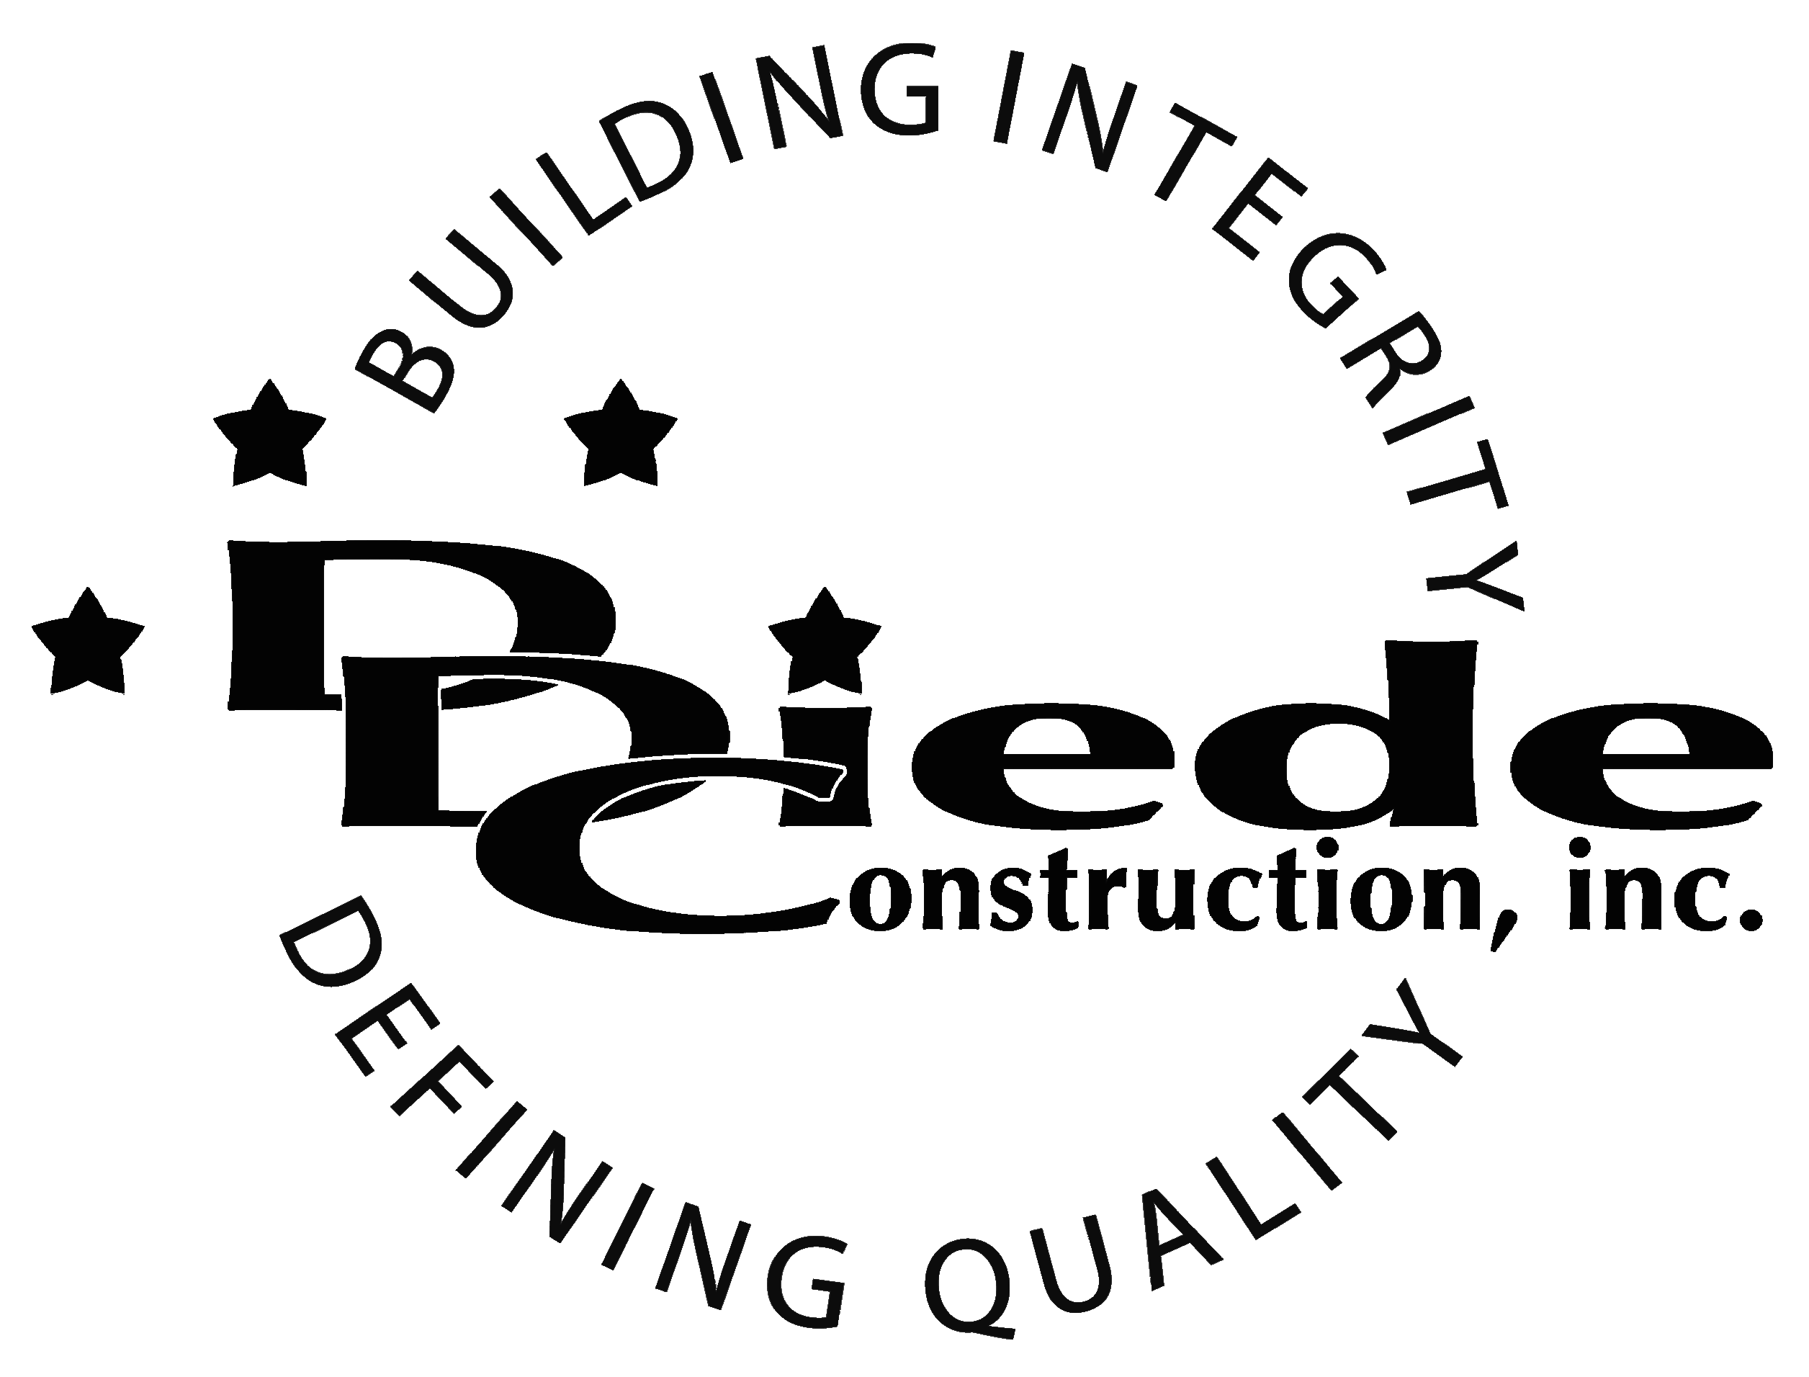
Diede Construction, Inc. Written 10/02/2017
Page 1 of 2

Title: Construction Sales
Company: Diede Construction, Inc.
Locations: Lodi
Description:
Construction Sales

Position Summary

Commercial Construction Sales at Diede Construction, Inc. has the responsibility of developing new business and maintaining existing business partnerships and relationships.

The Salesperson develops, designs, and implements marketing strategies in order to enhance the company’s ability to maximize its market presence and profitability.

This position stays up with new trends and developments in the construction industry and advises management on growth opportunities in current and new fields or industries.

Essential Functions
- Responsible for all aspects of Sales, including but not limited to:
        - Manage existing relationships.
        - Call on potential clients and develop new business
        - Provide clients with sales quotes, negotiate pricing and secure terms of sale
        - Visit sites and venues to gather information essential to the project
  - Follow up with clients and take appropriate actions to ensure customer satisfaction
  - Establish long and short term goals for business development
  - Increase market share by identifying and pursuing new opportunities
  - Complete all required Agreements and other reports in a complete, accurate and timely manner
- Communicate with:
        - Owners
        - Owners Reps
        - Community Representatives
        - Government Officials
        - Suppliers
        - Subcontractors
  - Prepare and deliver sales presentations to various groups including prospective and existing clients, government entities, community groups, etc.
  - Represent the company at trade shows, chamber of commerce events, community events and other events as necessary.
  - Identify events, speaking engagements, or other opportunities to get the company in front of potential clients
  - Meet with management, as appropriate, to review sales activities and prospective customers.
- The responsibilities of this position include, but are not limited to those listed above.

Knowledge & Skills
- Professional presentation. Must be confident, assertive, and able to display a high level of self-esteem.
- Proficient in using a computer and the below listed programs:
        - Microsoft Office (Outlook, Word, Excel, etc.), Excel knowledge a must
        - Estimating / Takeoff program knowledge
  - Must have strong organization and time management skills, and the ability to self-motivate.
  - Ability to multi-task under time constraints and working effectively as a team player in a professional office environment.
  - Strong communication skills both internally and externally and the ability to effectively communicate with managers, employees, vendors and others.
  - Strong active listening skills; able to give full attention to what is being said and take the time to understand the points being made. Can ask questions when appropriate and let others fully express their ideas.
  - Ability to identify information needed to clarify a situation. Can seek information from appropriate sources and the ability to handle problems that arise while anticipating future issues.
  - Excellent plan reading skills
  - Must have Construction knowledge
  - Proven Sales track record with a minimum of 5 years outside sales experience
  - Minimum 3 years’ experience working in the construction field in a similar or related position

Company Overview
Family-owned Diede Construction, Inc. (DDC) has grown its reputation by building with integrity since 1978. Today we design, build and manage properties throughout Northern California. The company continues to grow based on our ability to handle larger, more complex projects – projects requiring our signature creativity and our comprehensive services.
We build great buildings not by being big, but by thinking big. We build trust by treating our clients, employees and subcontractors like members of the Diede Family. We expedite projects by having a positive, focused attitude.

