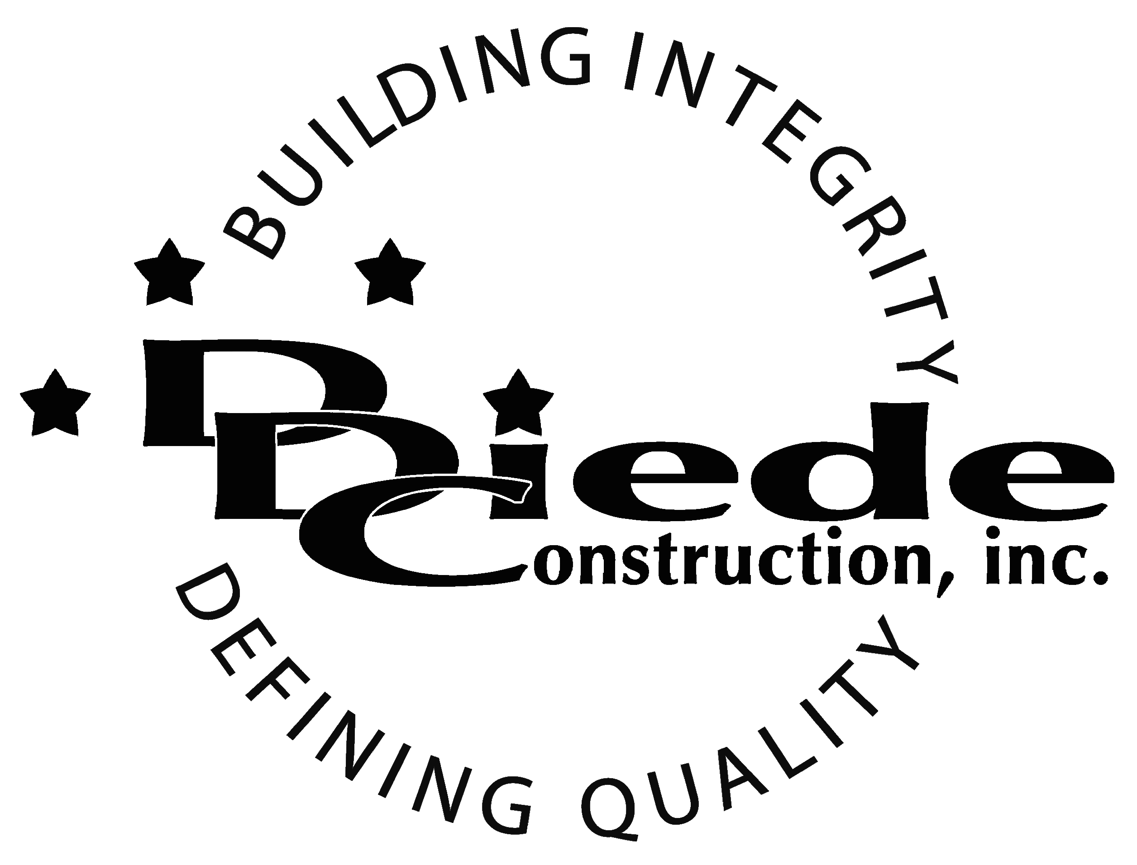
Diede Construction, Inc. Written 07/2//2016
Page 1 of 2

Title: Senior Accountant
Company: Diede Construction, Inc.
Locations: Lodi
Description:
Senior Accountant

Position Summary

The Senior Accountant is responsible for serving as a team leader in the finance department and ensuring that financial records for Diede Construction, Inc. are created accurately and in a timely fashion.

The Senior Accountant of Diede Construction, Inc. has the responsibility for working closely with Senior Management, Bookkeepers, and Operations teams and providing advice, documentation and administrative support as needed.

This position will require reviewing and updating procedures. The candidate must be willing to spearhead changes and create an environment that strives for efficiency and productivity.

Essential Functions
- Responsible for creating and analyzing accounting records, financial statements and other reports accurately following GAAP
- Works with Senior Management and finance to develop appropriate strategies and procedures for Diede Construction, Inc.
- Performs account audits to ensure accuracy.
- Maintains and audits company financial records.
- Follows and in some cases, develops SOPs for the Finance team.
- Performs duties relating to bookkeeping, tax reporting and government audits
- Creates and analyzes budgets
- Assist in year-end closing including:
        - Journal entry adjustments for depreciation expenses & fixed assets
        - Journal entries for any accruals
        - Reconciliation of Federal Income and State Taxes paid
        - Preparation of fiscal year end trial balance
        - Reconciliation of bank accounts, credit cards, and money accounts
        - Preparation of tax forms
- Collaborates as a consultant in areas such as compensation, benefits, and asset protection
- Provides training and mentoring to other members of the Financial team
- Tactful, Professional Demeanor with the ability to Interact Effectively and Communicate with:
        - Owners
        - Owners Reps
        - Suppliers
        - Subcontractors
        - Managers
- Collaborate with others on financial team and fill in or help as needed
- Special projects that include improving reporting, determining costs, preparing distinct financial packages for unique situations.
- The responsibilities of this position include, but are not limited to those listed above.

Knowledge & Skills
- CPA License preferred, but not required
- Proficient in using a computer and the below listed programs:
        - Microsoft Office (Outlook, Word, Excel, etc.)
        - Viewpoint or similar Construction Accounting software
        - Quickbooks
- Must be responsible and self-managed
- Must have excellent follow-up and tracking skills
- Must be hands --on, detail oriented and enjoy working in a fast-paced, rapid growth, family owned company environment.
- Must have a solid understanding of the accounting cycle.
- Experience in construction or manufacturing accounting
  - Professional presentation and conduct
  - Ability to multi-task under time constraints and working effectively as a team player in a professional office environment.
  - Demonstrates excellent verbal and written communication skills.
Company Overview
Family-owned Diede Construction, Inc. (DDC) has grown its reputation by building with integrity since 1978. Today we design, build and manage properties throughout multiple states. The company continues to grow based on our ability to handle larger, more complex projects – projects requiring our signature creativity and our comprehensive services.
We build great buildings not by being big, but by thinking big. We build trust by treating our clients, employees and subcontractors like members of the Diede Family. We expedite projects by having a positive, focused attitude.

