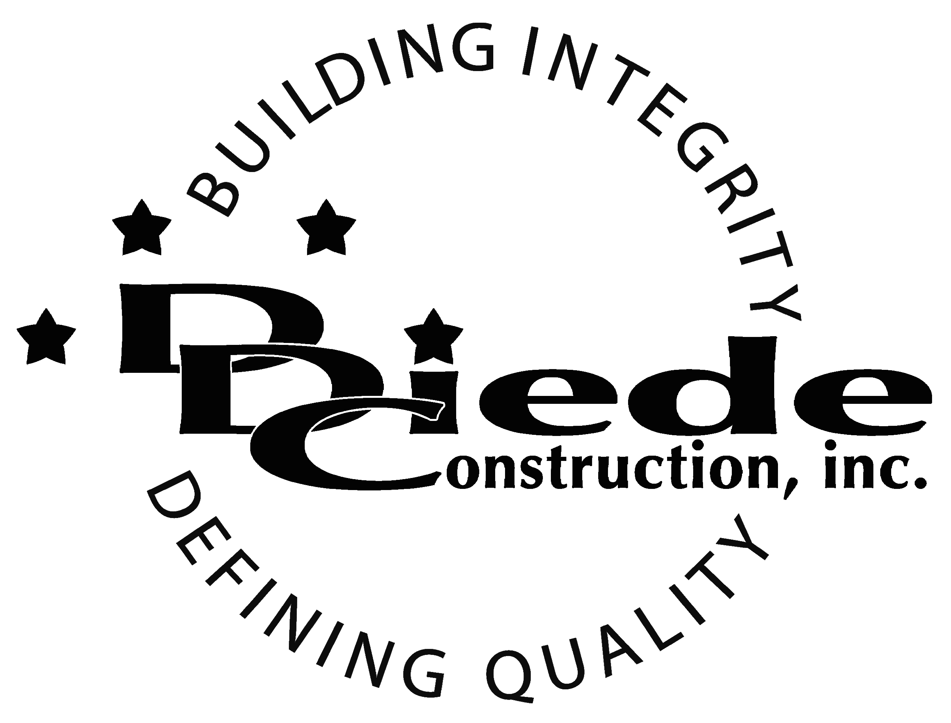
Diede Construction, Inc. Written 11/27/2017
Page 1 of 2

Title: Shop Maintenance Worker
Company: Diede Construction, Inc.
Locations: Lodi
Description:
Shop Maintenance Worker

Position Summary

The Shop Maintenance Worker delivers and maintains the Company’s equipment on jobsites and is responsible for the maintenance, upkeep, and return of rental equipment.

The Shop Maintenance worker maintains the shop in clean, safe condition and can be tasked with performing maintenance and cleanup duties in the shop and at jobsites.

The Shop Maintenance Worker is also in charge of maintaining a safe, clean work area and properly storing equipment and material so it is in working condition when it is needed.

Essential Functions
- Responsible for tracking and maintenance of company equipment including but not limited to:
        - Perform a variety of projects and activities to assure the delivery of service and equipment within established guidelines.
        - Respond to safety and/or operational concerns and takes appropriate action to resolve immediate safety issues and to help maintain a safe, functioning jobsite.
        - Respond to calls regarding disabled vehicles or equipment for the purpose of performing repair work in the field or getting the equipment back to the shop.
        - Read and interpret equipment manuals and work orders.
- Attend regularly scheduled safety and department meetings and training
- Assist with the return of rental equipment as requested by Project Managers and Superintendents
- Clean up jobsites
- Collaborate with field personnel (Super’s & Foremen)
- Communicate with:
        - Supervisors & Foremen
        - Suppliers
        - Subcontractors
- Report expenses to Shop Manager.
- Perform all work while complying to OSHA and Diede Construction, Inc. safety and health rules
- The responsibilities of this position include, but are not limited to those listed above.

Knowledge & Skills
- Must have strong problem-solving abilities.
- Operate construction equipment
- Ability to haul and pick up equipment and materials
- Operating standard office equipment

  - Must have strong organization and time management skills, and the ability to self-motivate.
  - Ability to multi-task under time constraints and working effectively as a team
  - Demonstrates excellent verbal and written communication skills.
  - Tactful, professional demeanor with the ability to interact effectively with managers, employees, vendors and others.

Company Overview
Family-owned Diede Construction, Inc. (DDC) has grown its reputation by building with integrity since 1978. Today we design, build and manage properties throughout Northern California. The company continues to grow based on our ability to handle larger, more complex projects – projects requiring our signature creativity and our comprehensive services.
We build great buildings not by being big, but by thinking big. We build trust by treating our clients, employees and subcontractors like members of the Diede Family. We expedite projects by having a positive, focused attitude.

