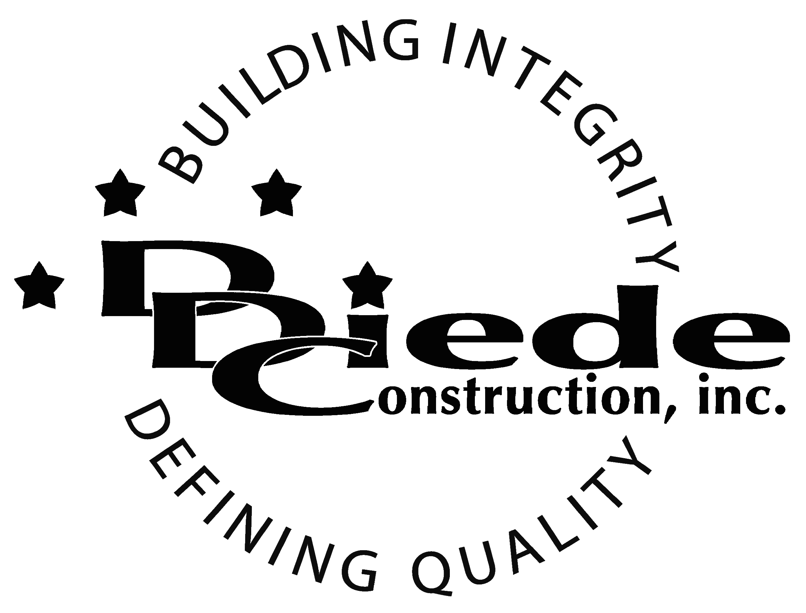
Diede Construction, Inc. Written 11/20/2017
Page 1 of 2

Title: Submittal Coordinator
Company: Diede Construction, Inc.
Locations: Lodi
Description:
Submittal Coordinator

Position Summary

The Submittal Coordinator provides overall support in the submittal process for multiple projects for our Project Management Teams.

The Submittal Coordinator of Diede Construction, Inc. has the responsibility of working closely with the Project Management team to ensure documentation is in order for successful proposals, bids and projects. This position also ensures that all shop drawings are completed and submitted within established timeframes.

The Submittal Coordinator is in contact with Project Managers, Architects and subcontractors, which requires tact, sensitivity, and professionalism.

Essential Functions
  - Ensures submittal packages are accurate and complete within established timeframes.
  - Tracks submitted documents from receipt to final disposition.
- Maintains submittal log accurately and up to date.
- Prepares document/submittal status reports as needed
- Assists the Project teams with document/submittal inquiries
- Maintains accurate records and files for future access
- Retrieves and packages submittal documents as project completion for archiving and warranty purposes
- The responsibilities of this position include, but are not limited to those listed above.

Knowledge & Skills
- Proficient in using a computer and the below listed programs:
        - Microsoft Office (Outlook, Word, Excel, etc.)
  - Must have strong organization and time management skills, and the ability to self-motivate.
  - Ability to multi-task under time constraints and working effectively as a team player in a professional office environment.
  - Demonstrates excellent verbal and written communication skills.
  - Ability to perform duties in a professional manner and appearance.
  - Tactful, professional demeanor with the ability to interact effectively with managers, employees, vendors and others.
  - Familiarity with CAD shop drawing concepts and practices
  - Knowledge of methods, design, or practices of commercial construction
  - Associates degree in a related field or the equivalent experience

Company Overview
Family-owned Diede Construction, Inc. (DDC) has grown its reputation by building with integrity since 1978. Today we design, build and manage properties throughout Northern California. The company continues to grow based on our ability to handle larger, more complex projects – projects requiring our signature creativity and our comprehensive services.
We build great buildings not by being big, but by thinking big. We build trust by treating our clients, employees and subcontractors like members of the Diede Family. We expedite projects by having a positive, focused attitude.

