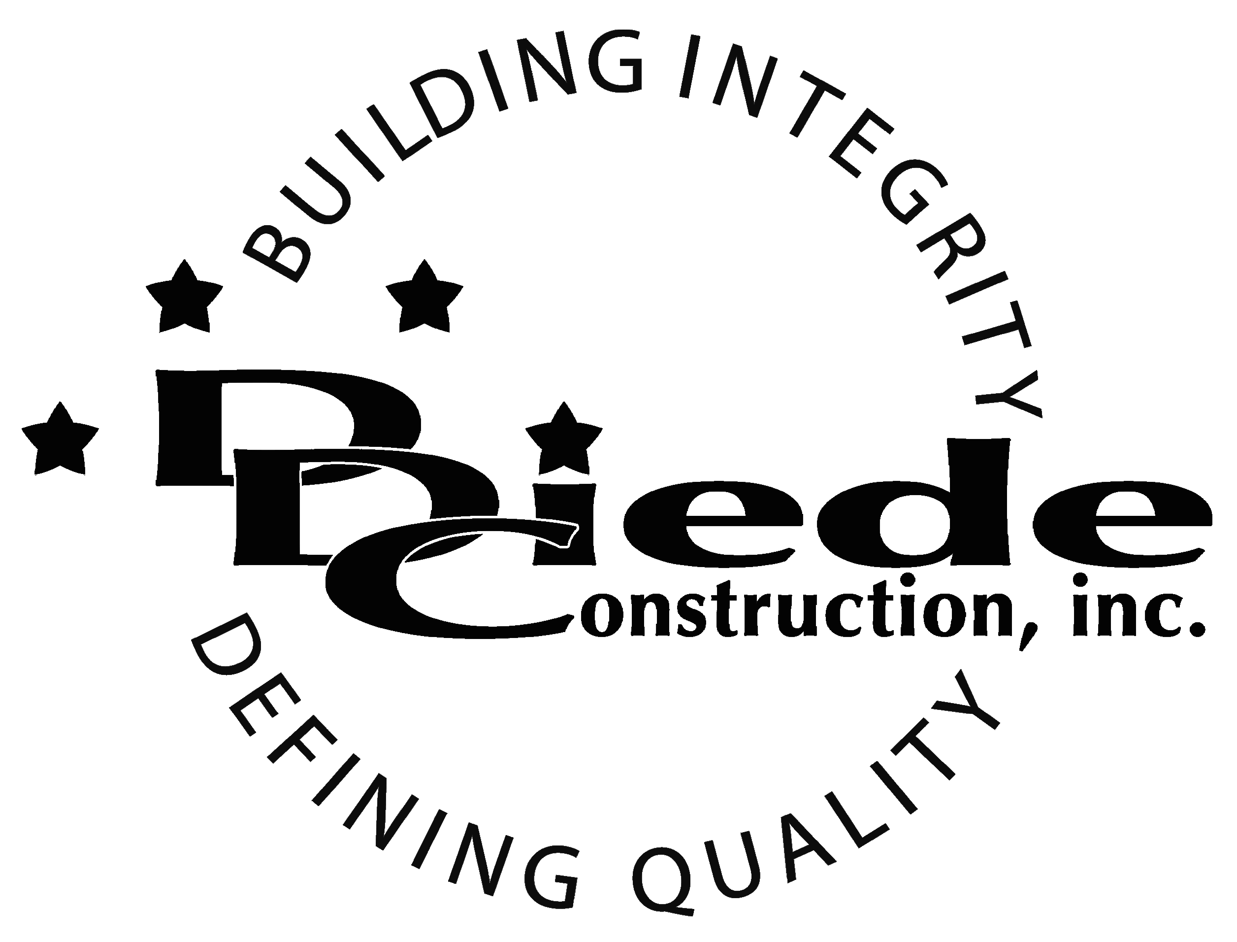
Diede Construction, Inc. Written 09/08/2014
Page 1 of 2

Title: Construction Superintendent
Company: Diede Construction, Inc.
Locations: Lodi
Description:
Construction Superintendent Safety Officer

Position Summary

The Superintendent provides leadership on their project and is responsible for the overall field supervision of the commercial construction project.

The Superintendent of Diede Construction, Inc. has the responsibility to work closely with the Project Management team to ensure the success of the project.

The Superintendent is in contact with DDC personnel, Amtrak, customers, subcontractors, inspectors, and city officials, which requires tact, sensitivity, and professionalism.

The Superintendent will additionally plan and implement Amtrak and Host Railroad Safety on site to ensure a safe, also, works with the project team to ensure that the best possible outcome is achieved.

Essential Functions
- Responsible for all day to day operations on the project site including but not limited to:
        - Scheduling subcontractors
        - Scheduling DDC personnel
        - Ordering Material
        - Troubleshooting
        - Paperwork
- Walk and inspect construction site daily to verify compliance with company and OSHA safety requirements.
- Material takeoffs
- Communicate with:
        - Owners
        - Owners Reps
        - Suppliers
        - Subcontractors
        - City officials
        - Inspectors
        - DDC Personnel
- Complete knowledge of subcontracts
- Understanding of project documents
- The responsibilities of this position include, but are not limited to those listed above.
- Willingness to travel
- Drug Testing Required

Safety
- Ensure that this is a healthy and accident-free work environment on during the project for direct hire individuals and sub-contractors, alike with the following expectations:

        - Safety goals are achieved on every project
        - No accidents or near misses
        - No OSHA citations.
        - Employees have a positive attitude toward safe work practices
        - Employees are well-educated in safe practices and have all the resources necessary to work safely
        - Observe and practice all governmental safety regulations, project requirements and company safety policies
        - Analyzes and recommends corrective action for all accidents
        - Point of contact for Owner/Client Safety Representatives
        - Post all safety bulletins, safety posters, safety rules, and applicable legislation
        - Coordinate the transportation of injured employees to a physician's office or hospital
        - Maintain relations with project physicians, the workers' compensation case nurse, ambulance service, fire department and hospitals
        - Test and be Accredited for Amtrak and Host Railroad Safety

Knowledge & Skills
- Proficient in using a computer and the below listed programs:
        - Microsoft Office (Outlook, Word, Excel, etc.)
        - P6 knowledge preferred
  - Must have strong organization and time management skills.
  - Ability to multi-task under time constraints and work effectively as a team player.
  - Demonstrates excellent verbal and written communication skills.
  - Ability to perform duties in a professional manner and appearance.
  - Tactful, professional demeanor with the ability to interact effectively with managers, employees, vendors and others.
  - Ability to read and understand plans and specifications.
  - Ability to encourage and motivate your construction team.
  - Public works experience a must.
Company Overview
Family-owned Diede Construction, Inc. (DDC) has grown its reputation by building with integrity since 1978. Today we design, build and manage properties throughout several surrounding states. The company continues to grow based on our ability to handle larger, more complex projects – projects requiring our signature creativity and our comprehensive services.
We build great buildings not by being big, but by thinking big. We build trust by treating our clients, employees and subcontractors like members of the Diede Family. We expedite projects by having a positive, focused attitude.

